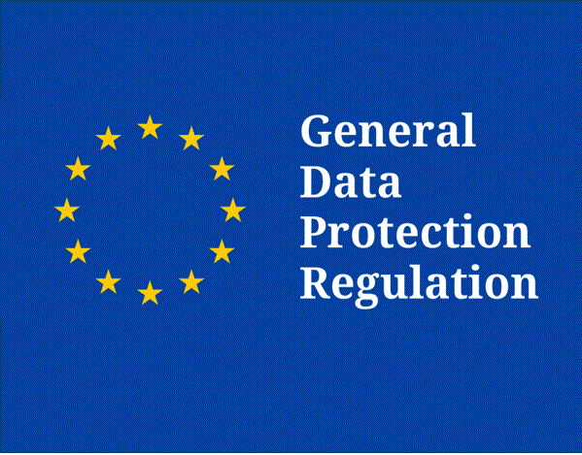

Capita SIMS – Software developments to support GDPR compliance

Capita SIMS – Software developments to support GDPR compliance

SIMS Parent Lite app:
Included within your SIMS annual entitlement fee, the SIMS Parent Lite app helps schools comply with the new GDPR data requirements, by providing a simple way to collect, manage and handle information by obtaining accurate data securely from parents.

Supports GDPR data accuracy:
- Collect the most up-to-date data about students and their parents, to comply with the GDPR requirement for accuracy of data.
- Available on iOS, Android and a browser, the SIMS Parent Lite app provides a convenient and accessible solution for parents to electronically review and request changes to the data held on them and their children.
- Schools have the ability to send notifications to parents, reminding them to update their details, reducing manual data entry and eliminating paper based data collection.

Safe data transfer:
- The SIMS Parent Lite app allows users to use an existing email account to login, removing the need for a school to manage user accounts.
- Parents can provide additional information on crucial details such as medical information or dietary requirements, using the text information function, ensuring that personal information not previously held in SIMS is collected.

Supports data upkeep
- When a parent has submitted a change request, automatic emails are sent to nominated SIMS admin accounts. Administrators are able to view previous requests and details of any action taken via the audit trail within SIMS.

Person Data Output:

The ‘right to access’ is one of eight rules under the title of ‘Individual Rights’ and builds upon existing Data Protection Act legislation in the form of a Subject Access Request (SAR). When a school receives a SAR, there will be many separate reports in many different formats that a user in SIMS will need to produce to fulfil the request. This can be time consuming and a burden, to help address this, Capita have introduced some new functionality called the Person Data Output (PDO).
Initially the PDO will be available for Students with the export being introduced for Staff in the Spring 2018 release with options for outputs in a machine readable format (‘Data Portability’).

Data retention: Capita statement
Where a school has a data retention policy in place, we know that implementing this in SIMS is difficult. We know that while a user is able to delete data from a record, it is not possible to do this in bulk, something that customers have been requesting for a number of years. This particular process has been considered many times for SIMS, but other pressures on statutory requirements has led us not to develop this type of functionality.
While the requirements around data retention under GDPR is not significantly different from the Data Protection Act, we must address this and make a concerted effort to make improvements in 2018. This feature (as with deletion mentioned below) is very complicated and will require a significant amount of analysis and development as there are many things we need to consider. Our plan is to start work on this during the Summer construction phase of the software (this is initiated around the end of January 2018), but due to the complexities, it is likely that the functionality won’t be ready until the Autumn of 2018.

Deletion of Data: Capita statement

Where the data retention work is focused on deleting pockets of data, i.e. Achievements, from a selection of Students, i.e. those who left the school 10 years ago, for a date range, this deletion is the deletion (or where required, anonymisation) of an entire persons record, this is referred to under GDPR as ‘the right to be forgotten.’
Like data retention, this is not a simple task, we have to consider how SIMS copes with linked records, previously run statutory reports and such a like, care will be given to the analysis of this work and we would hope to deliver this functionality in the Autumn of 2018.

Capita have also produced a number of Privacy Notices, primarily for what they term their satellite products.

Privacy Notices are available for:

- SIMS Activities
- SIMS Agora
- SIMS InTouch
- SIMS Options Online
- SIMS Parent
- SIMS Parent Lite
- SIMS SchoolView
- SIMS Student
- SIMS Teacher App

