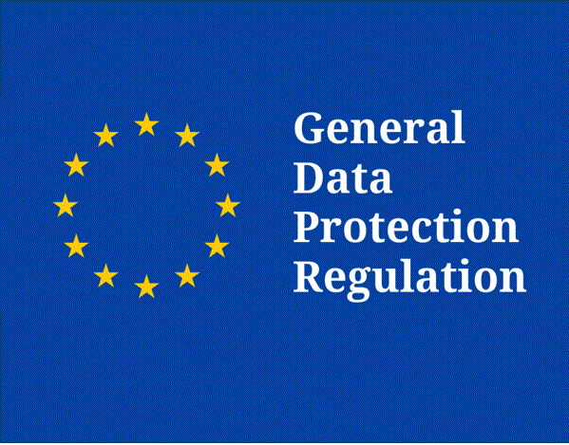

ICT Development Service
Suppliers and Services
GDPR Compliance

Welearn365:
This service includes the provision, maintenance and support of a customised instance of Microsoft’s Office365 product. In brief it provides subscribing schools and academies with the following services and features:
- Individual email accounts for pupils, staff and governors
- Access to a customised SharePoint school site
- Access to Microsoft modules and applications
- Access to specific third party educational resources (Purple Mash, J2E – see below)

The service is built around a single Active Directory (AD) that provides user authentication for both WeLearn365 and Warwickshire Curriculum Networks. This allows users to access both systems using the same login details.

Microsoft Office365 GDPR Compliance:

Microsoft Office 365 encrypts all customer content at rest and in motion using multiple encryption technologies. In addition, each Office application, such as Word, Excel, and PowerPoint, enables you to encrypt documents.

OneDrive for Business and SharePoint Online encrypt all personal data in transit. By default, all Skype-to-Skype voice, video, file transfers, and instant messages are encrypted. By default, Exchange Online encrypts communications between Office 365 and Exchange Online servers and between Exchange Online customers. Customer data within Office 365 is protected by various forms of encryption and is encrypted both at rest and in transit. For data at rest, Office 365 uses BitLocker, Azure Storage Service Encryption, and Office 365 Service Encryption. For data in transit, Office 365 uses multiple encryption technologies, including Transport Layer Security (TLS) and Internet Protocol Security (IPsec).

Data within OneDrive is stored within the EU and is fully encrypted and compliant with GDPR. Microsoft implements advanced data protection and security features in its cloud services to safeguard data and privacy.

For more information on Microsoft’s GDPR Compliance, please see links below:

https://privacy.microsoft.com/en-GB/privacystatement
https://www.microsoft.com/en-us/trustcenter/privacy/gdpr/solutions

Groupcall:
The ICT Development Service uses a number of Groupcall products to support the delivery of services to schools and the wider Local Authority.
Xporter – This is the client that is used by ICTDS and many third party MIS systems to move data from your school MIS (typically SIMS) and deliver it to our central systems for purposes such as provisioning email/AD accounts and CME.
IDaaS – This is the cloud based Identity Management Service that ICTDS use to create secure single sign-on WeLearn accounts for students and staff.
XVault – This product stores all of the MIS data received from schools in a secure SQL database.

Groupcall GDPR Compliance:
Groupcall has standardised policies to manage and protect the data that they process on behalf of customers. They have significant experience in the education sector and in cloud computing, processing data for around 7.5 million students every day. Their policies are driven by this experience, their ISO 27001 and ISO 9001 accreditations and their existing data protection compliance through their ICO registration.

For more information on Groupcall’s GDPR Compliance, please see link below:
https://www.groupcall.com/our-gdpr-compliance?__hstc=12302699.135e4c03a4881d8eb5ab97b58127074a.1463576086363.1519658420710.1521127142485.15&__hssc=12302699.4.1521127142485&__hsfp=1984219710

Redstor Backup:
The backup service is included in Full Server Support Cover. Remote backup of your file server is carried out using Redstor Backup Plus for all your documents and SIMS data. (Redstor Backup Plus is approved by Capita as a backup system for SIMS data storage). Data is backed up on a daily basis and is kept for a maximum of 60 days.

Redstor GDPR Compliance:
Redstor are an ISO 27001 and 9001 certified organisation with 20-years’ experience in managing and protecting data across multiple platforms for organisations of all sizes. Redstor have implemented and documented data protection policies that ensure all aspects of the General Data Protection Regulation are upheld with regards to backup data and working with data processors.
See Appendix 1. for Redstor GDPR Compliance statement

Future Digital:
This software is used to provide our centrally managed monitoring service (Digital Safeguarding). We monitor desktop activity on all Windows PCs in the school.

Future Digital GDPR Compliance:
See Appendix 2. for Future Digital GDPR Compliance statement

Smoothwall:
Web Filtering is Included as part of your Broadband contract using ‘Smoothwall’ technologies; an industry leading product especially suited to an educational environment.

Smoothwall GDPR Compliance:
Smoothwall does not collect, store, use, process or handle in any way any of the personal data collected by the UTM/SWG, and it is therefore neither a data controller nor a data processor in respect of the UTM/SWG for the purposes of GDPR or the UK data protection regime.

The UTM/SWG only collects:
• the address or URL of any webpage which a user tries to access
• the words entered into a search engine and
• the fact that an attempt to access a restricted site has been made,
and logs this information against the username.
ICT Development Service as a data processor, has the ability to configure the settings within the UTM/SWG to allocate users to specific user groups, such as a year group at a school. We are confident that allocating users to groups in this way satisfies the requirement to only collect the data which is necessary for the purposes of the processing.

Access to user data is controlled. Careful configuration of the UTM/SWG’s user portal is made to ensure that only those who should have access specific user data are permitted to do so.

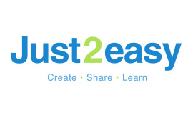

Just2Easy (J2E):
J2E resources provide a variety of tools to support learning in the classroom.

J2E GDPR Compliance:
For more information on J2E GDPR Compliance, please see link below:
https://www.just2easy.com/privacy/index.html

2Simple - Purple Mash:
Premium educational resources from 2Simple to support learning from early years right through to the end of key stage 2. Our unique package includes Serial Mash (online reading books and related resources) and 2Simple French. For Warwickshire schools, Purple Mash resources are accessed via the WeLearn portal.

Purple Mash GDPR Compliance:
For more information on Purple Mash GDPR Compliance, please see links below:
https://static.purplemash.com/mashcontent/applications/documents/terms_and_conditions//Purple%20Mash%20terms%20and%20conditions.pdf
https://www.purplemash.com/mashcontent/applications/documents/privacypolicy/Purple_Mash_Privacy_Policy.pdf

