Post 16 Data Preparation Check List for the School Census Autumn 2023 Return
Use this check list to tick off each of the preparation tasks when they have been completed.

Complete | Description
 | Upgrade to the SIMS 2023 Summer Release (7.212) or later.
 | Ensure that Maths and English GCSE are recorded for Maths and English GCSE please refer to the Processing Results and Calculating PI Data in Exams and SIMS handbook).
 | Ensure that Maths and English GCSE Prior Attainment (i.e. grade achieved) is recorded for each student in year 12 and above (please see Recording External Exam Results for Prior Attainment on page 5).
To ensure that the correct Prior Attainment information is collected in the return:
▪ Check that all Prior Attainment data has been updated for 2022/2023 (please see Updating Prior Attainment for 2021/2022 on page 27)
▪ Correct Maths and English highest grades for 2022/2023, if required (please see Correcting 2022/2023 Prior Attainment for Resubmitting in the Autumn Census on page 7).
 | Check that Census View is set as the Default for Course Browse (please see Checking the Default for Course Browse on page 9).
 | Check the appropriate default course durations are set up (please see Checking Default Course Durations on page 9).
 | Check that the Earliest Year Taught In for Completion Management is set to Curriculum Year 11 or above (please see Checking the Earliest Year Taught In for Completion Management on page 10).
 | Check that the appropriate default completion and continuity tolerance are set up (please see Checking Default Completion and Continuity Tolerance on page 11).
 | Check the default course duration and tolerances by level (please see Checking the Default Course Duration and Tolerances by Level on page 12).
 | Run the Bulk Update of course end dates routine to remove August end dates (please see Running the Remove August End Dates Routine on page 14).
 | Run the Bulk Update of course end date routine using completion tolerance to reset status (please see Running the Using Completion Tolerance to Reset Status Routine on page 14).
 | Record leavers and update course membership (please see Recording Leavers and Updating Course Memberships on page 15).
Check that the Learning Aim withdrawal reason has been recorded to explain why the student is leaving the learning aim before the expected end date (please see Checking Membership and Results on page 36).
Ensure that the Learning Aim withdrawal reason is also recorded for any Leavers (please see Recording Leavers on page 16).
 | Check that the Core Learning Aim has been set for students, where applicable (please see Checking Core Learning Aims on page 19).
 | Update Funding and Monitoring details as required by the DfE (please see Updating Funding and Monitoring on page 25).
 | Download the QAN catalogue from the DfE QAN website (https://collectdata.education.gov.uk/qwsweb/default.aspx) and imported into SIMS in September before starting the School Census Autumn 2022 Return (please see Importing Catalogue Files on page 29).
 | Ensure the required QANs and Discount Codes are available for selection in Course Manager (please see Updating QANs and Discount Codes for Course Manager on page 31).
 | Check course duration for individual courses (please see Checking the Course Duration for an Individual Course on page 33).
 | Check that there is only one award associated with each course (please see Checking Examination Award Details on page 34).
 | Select the additional attributes for each course, e.g. the Code, if required, and ensure that the To date is entered for any 'old' codeset (please see Selecting Additional Attributes for a Course on page 35).
 | If applicable, ensure that the Provider UKPRN (United Kingdom Provider Reference Number) is entered for each Learning Aim (please see Checking Membership and Results on page 36).
 | Check that the course status is correct, e.g. Withdrawn and Transferred (please see Checking Membership and Results on page 36).
 | Ensure that traineeships are indicated where applicable (please see Indicating Traineeships on page 38).
 | Ensure all Work Placements are recorded (please see Work Placements on page 44).
To ensure that the correct Post 16 programmes of study information is collected in the return:
▪ Check that programmes of study information has been recorded for the 2022/2023 academic year (please see Maintaining Post 16 Programmes of Study on page 46).
▪ Correct planned hours for 2022/2023, if required (please see Correcting 2022/2023 Planned Hours on page 7).
 | Check that employment information for Post 16 students has been added, where applicable (please see Recording Post 16 Employment Information on page 52).
 | Use the Edit PI Data routine to ensure that non-EDI exam information for prior attainment is available in School Census (please see Managing Non-EDI Exam Information on page 56).

- Contents
01| Introduction 1
About this Guide 1
About Post 16 Learning Aims 1
What Post 16 Data is Collected? 2
Setting SIMS Permissions 3
What Version of SIMS is Required? 4
02| Preparing Data for the Previous Academic Year 5
Chapter Overview 5
Recording External Exam Results for Prior Attainment 5
Correcting 2022/2023 Prior Attainment for Resubmitting in the Autumn Census 7
Correcting 2022/2023 Planned Hours 7
Checking Course Manager Settings 8
Checking the Default for Course Browse 9
Checking Default Course Durations 9
Checking Discount Results Selection 10
Checking Planned Hours Threshold 10
Checking the Earliest Year Taught In for Completion Management 10
Checking Default Completion and Continuity Tolerance 11
Checking the Default Course Duration and Tolerances by Level 12
Running the Bulk Update Courses Routines 13
Running the Remove August End Dates Routine 14
Running the Using Completion Tolerance to Reset Status Routine 14
Recording Leavers and Updating Course Memberships 15
Recording Leavers 16
Updating Course Memberships 18
Event Driven Recording of Learning Aims Status 18
Checking Core Learning Aims 19
Editing a Core Learning Aim via the Student Courses Page 20
Editing a Core Learning Aim via the Memberships and Results Panel 22
03| Preparing Data for the Current Academic Year 25
Chapter Overview 25
Updating Funding and Monitoring 25
Updating Prior Attainment for 2022/2023 27
Importing Catalogue Files 29
Updating QANs and Discount Codes for Course Manager 31
Checking Course Manager Data for the Current Academic Year 33
Checking the Course Duration for an Individual Course 33
Checking Examination Award Details 34
Selecting Additional Attributes for a Course 35
Checking Membership and Results 36
Indicating Traineeships 38
Setting up Courses for T Level 39
Work Placements 44
Adding the First Work Placement Record for a Student 44
Finding your way Around the Work Placement Panel 45
Maintaining Post 16 Programmes of Study 46
Calculating Programmes of Study 46
Recording Planned Hours 47
What features are available to facilitate the completion of the Maintain Post-16 Programmes of Study page? 50
Recording Post 16 Employment Information 52
04| Additional Information 55
Managing Performance Indicators 55
Managing Non-EDI Exam Information 56
School Census Autumn 2023 Reports 59
Post-16 Programmes of Study Report 59
Post-16 Programmes of Study and Learning Aims Report 59
Post-16 Funding and Monitoring Report 60
Where Can I Get More Information 60
SIMS 7 Documentation 60
SIMS 7 Newsfeeds 61
DfE Information 61
Index 63

Introduction
About this Guide 1
About Post 16 Learning Aims 1
What Post 16 Data is Collected? 2
Setting SIMS Permissions 3
What Version of SIMS is Required? 4

About this Guide
This Preparation Guide has been produced to help identify the most common Post 16 tasks that need to be carried out before running the School Census Autumn 2023 Return.
The guide is applicable to English maintained Secondary/middle deemed Secondary and All-Through schools, Pupil Referral Units, CTCs and Academies that have sixth form students.
For information about preparation tasks outside of the Post 16 area, please refer to the Preparing for the School Census Autumn 2022 (English Secondary/Middle deemed Secondary schools) guide. The preparation guide, together with other useful School Census documentation, is available from the SIMS Documentation Centre (accessed via the Documentation button, which is located on the top right-hand side of the SIMS Home Page).
NOTE: The contents of the graphics (dates, names, etc.) in this guide are examples only of what you might expect to see when using SIMS to prepare for the forthcoming School Census return.

About Post 16 Learning Aims
Schools with a Sixth Form are required to provide details about Learning Aims once a year in the School Census Autumn Return.
The return collects information about Learning Aims that were undertaken during the academic year 2022/2023 as well as those that were started or continued during the academic year 2023/2024. Learning Aims are collected for students taught in Year 12 and above during the Learning Aim collection period (01/08/2021 to 05/10/2022).
Schools must ensure that the Learning Aims submitted in the return are those for which they wish to claim funding. Local Authorities and Academies should refer to the DfE website (https://www.gov.uk/government/collections/funding-education-for-16-to-19-year-olds) for relevant information.

What Post 16 Data is Collected?
The following Post 16 information is collected in the School Census Autumn 2022 Return:
- Programme Aim information:
- Qualification Accreditation Number (QAN) - now known as Qualification Number (QN)
- Programme Aim key dates:
- Start Date
- Planned End Date
- Actual End Date.
- Current Status of the Programme Aim, i.e. Completed, Continuing, Withdrawn or Transferred
- Programme Type, i.e. Study Programme, T Level or T Level Transition
- Programme Aim Withdrawal Reason
- Traineeship - an education and training programme.
- Learning Aims information:
- Qualification Accreditation Number (QAN) - now known as Qualification Number (QN)
- Discount Code - now known as Subject Classification Code (SCC)
- Learning Aim key dates:
- Start Date
- Planned End Date
- Actual End Date.
- Current Status of the Learning Aim, i.e. Completed, Continuing, Withdrawn or Transferred
- Learning Aim withdrawal reason, e.g. illness, injury, etc. (please see Recording Leavers on page 16)
- Programme Type, i.e. Study Programme, T Level or T Level Transition
- Core Aim (the primary Learning Aim being undertaken in a student's programme of study)
- Partner UKPRN - sub-contracting UK partner
- Traineeship - an education and training programme.
- Work Placement:
- Start date and end date
- Hours
- Internal/External placements
- Employer ID.
- Planned Qualification Hours and Planned Non-Qualification Hours.
- Maths and English GCSE Prior attainment for each student in year 12 and above for whom Learning Aims are collected.
- Funding and Monitoring:
- Student in receipt of 16-19 Tuition Fund (code 21)
- Student repeating Post 16 year (code 22).
NOTE: All Learning Aims are collected regardless of their duration, provided the dates are within the collection period, i.e. from 01/08/2021 to 06/10/2022, except for T Levels from 01/08/2021 to 31/07/2023.
Learning Aims data is collected for students within the following parameters:
For the Previous Academic Year (2022/2023):
Any student, regardless of age, who has been on-roll between the 01/08/2021 and 31/07/2022 who has participated in a Learning Aim whilst in National Curriculum Year 12 or above.
In the Current Academic Year (2023/2024):
Any student, regardless of age, who has been on-roll between the 01/08/2023 and 05/10/2023 (census day) who has participated in a Learning Aim whilst in National Curriculum Year 12 or above.
Dual Registered Students
Funding is only provided to the student's main school and the Learning Aims for dual registered students must be returned by the main school. Subsidiary schools must not submit Learning Aims for dual registered students who are not on-roll at their school.

Setting SIMS Permissions
The following permissions are applicable to users who deal with returns.

Running the Return
To run the return, you must be a member of one of the following user groups in System Manager:
- Returns Manager
- Returns Operator.

Editing and Preparing Data
Users who edit and prepare data must have permissions to access additional areas of SIMS, e.g. student details, school details, etc. These users must be a member of the user groups applicable to the areas they are editing (please see Where to find More Information about Permissions on page 4).
Users who edit and prepare Post 16 data must have permissions to access Course Manager and Examinations Organiser. These users must be a member of the following user groups in System Manager:
- Curricular Manager
- Exams Officer.

Permissions Required to Import a Revised Fileset
The Import Fileset functionality enables updates to the Validation Errors Summary and the Summary report (derived from files supplied by the Statutory Body), and detail reports (provided by SIMS) to be imported into SIMS between SIMS releases.
To use the Import Fileset functionality (via Tools | Setups | Import Fileset), you must be a member of one of the following user groups in System Manager:
- Returns Manager
- System Manager.
For more information about the Import Fileset functionality, please refer to the applicable preparation guide. To access the SIMS Documentation Centre. Click the Documentation button located on the top right-hand side of the SIMS Home Page.

Where to find More Information about Permissions
Please contact your System Administrator/Manager if you are not sure whether you have the required permissions. For more information, please refer to the Managing SIMS Users, Groups and Databases handbook.
The SIMS Permissions spreadsheet describing the numerous permissions available in SIMS is available on the support portal (https://customer.support-ess.com/csm?id=kb_article_view&sysparm_article=KB0036819).

What Version of SIMS is Required?
To run the return, you must have the SIMS 2023 Summer Release (7.212) or later installed.
To check which version of SIMS is installed, open SIMS and then select Help | About SIMS.
The version should read 7.206 or later.

Preparing Data for the Previous Academic Year
Chapter Overview 5
Recording External Exam Results for Prior Attainment 5
Correcting 2022/2023 Prior Attainment for Resubmitting in the
Autumn Census 7
Correcting 2022/2023 Planned Hours 7
Checking Course Manager Settings 8
Running the Bulk Update Courses Routines 13
Recording Leavers and Updating Course Memberships 15
Event Driven Recording of Learning Aims Status 18
Checking Core Learning Aims 19

Chapter Overview
This chapter provides guidance about the tasks that need to be performed to ensure that the Post 16 data for the previous academic year is complete and accurate in time for the forthcoming School Census return on 05/10/2023.

Recording External Exam Results for Prior Attainment
To calculate Prior Attainment in GCSE Maths and English using exams data, please ensure the applicable steps are carried out.
EDI Results
Ensure that Electronic Data Interchange (EDI) Results have been downloaded and imported into Examinations Organiser for internal candidates before dealing with results for external candidates.
External Results Manual Entry
Examinations Officers can add external examination results achieved at another centre (usually another school) via Tools | Examinations | External Results Manual Entry in SIMS. Depending on the QN, a number of fields are populated automatically but exam results must be entered manually. Prior attainments can be entered for students, particularly those joining the Sixth Form who have already achieved GCSE results elsewhere.
External Exam Results
It is possible to include external exam results in a CTF file. This is achieved by selecting the External Exam Results check box in the applicable panels via Tools | Setups | CTF.
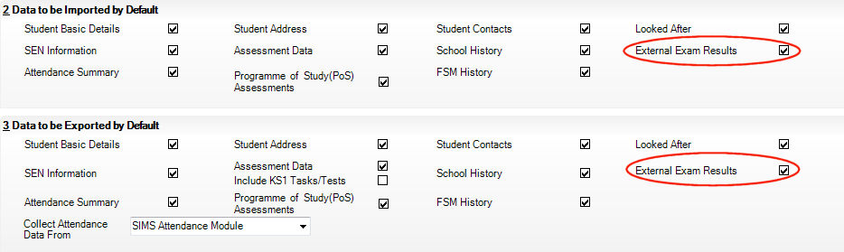
IMPORTANT NOTES:
External exam results added via Tools | Examinations | External Results Manual Entry in SIMS are not included in the PI calculations.
Any results achieved at another centre that are required for inclusion in the PI calculations must be entered in SIMS via Tools | Examinations | Edit PI Data (please see Managing Performance Indicators on page 55).
When entering examination results manually, it is not necessary to import the associated basedata. Results cannot be entered for external candidates.

Additional Resources:
Administering and Registering Candidates for Exams handbook (includes information regarding manual entry of external results)
Processing Results and Calculating PI Data in Exams and SIMS handbook (includes information regarding manual entry of external results)
Managing Pupil/Students handbook (includes information regarding the inclusion of external exam results in CTF import and export)

Completed

Correcting 2022/2023 Prior Attainment for Resubmitting in the Autumn Census
Schools can make corrections to the Maths highest grades and English highest grades that were submitted in last year's Autumn School Census. These grades are then re-submited in the 2023 Autumn School Census.
The Effective Date displays the 2022 Autumn census date. This field is read-only.
- Select Tools | Statutory Return Tools | Update Prior Attainment to display the Update Prior Attainment page.
- Select the 2022/2023 Academic Year from the drop-down list to display the information collected in last year's Autumn census.
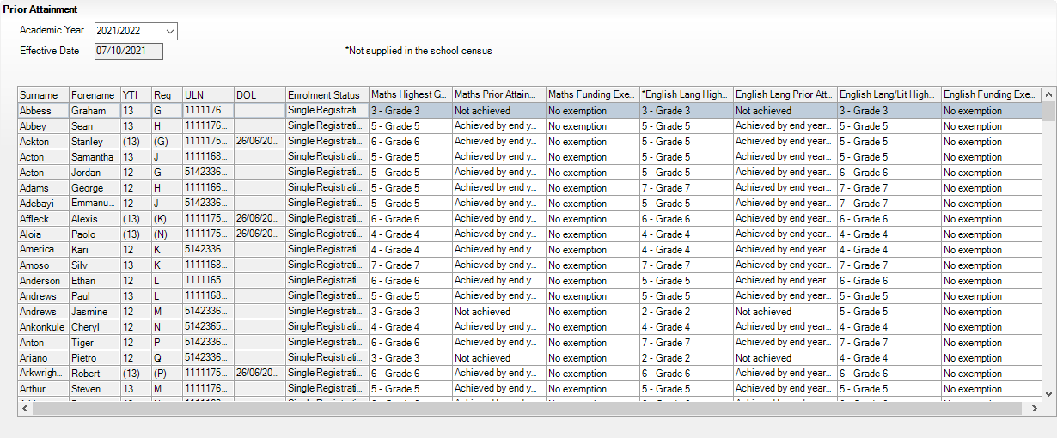
- Edit the information in the Maths Highest Grade and/or English Highest Grade columns, if required.
- Click the Save button.

Completed

Correcting 2022/2023 Planned Hours
The Planned Hours for the previous academic year (2022/2023) are included in the Autumn School Census. Schools can make corrections to these planned hours and then re-submit in the 2023 Autumn School Census, if required. This is not applicable to T Levels.
The Effective Date displays the previous Autumn census date. This field is read-only.
- Select Tools | Academic Management | Course Manager | Post-16 Programmes of Study to display the Maintain Post-16 Programmes of Study page.
- Select the 2021 Autumn Census from the drop-down list to display the relevant information.
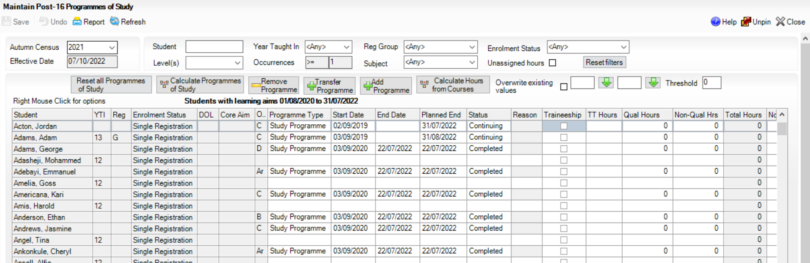
- Edit the Qual Hours and/or Non-Qual Hrs, if required.
- Click the Save button.

Completed

Checking Course Manager Settings
The Update Course Manager Settings page enables you to specify the default settings that will be used throughout Course Manager. These settings are applied to all courses unless you manually modify the parameters of a specific course from the Course Details page (Tools | Academic Management | Course Manager | Maintain Course).
Select Tools | Academic Management | Course Manager | Course Manager Settings to display the Update Course Manager Settings page.
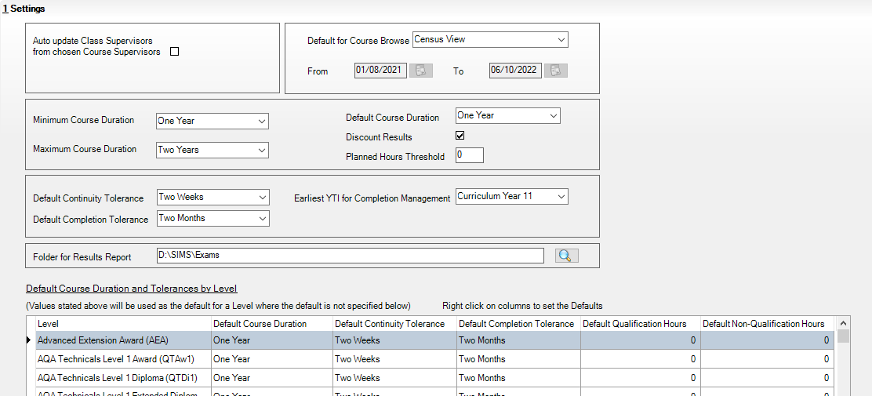

Checking the Default for Course Browse
Select Tools | Academic Management | Course Manager | Course Manager Settings to display the Update Course Manager Settings page.
Ensure that Census View is selected from the Default for Course Browse drop-down list. The From and To dates are displayed automatically to reflect the your selection.
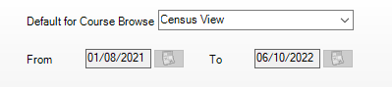
When you Search for courses in the Find Course browser (Tools | Academic Management | Course Manager | Maintain Course), only courses that have student memberships during this date range are displayed.

Completed

More Information:
Checking the Default Course Duration and Tolerances by Level on page 12
Checking the Course Duration for an Individual Course on page 33

Checking Default Course Durations
Select Tools | Academic Management | Course Manager | Course Manager Settings to display the Update Course Manager Settings page.
The Minimum and Maximum Course Duration fields enable you to define the predicted length of time needed to deliver the course material to the students. The Minimum Course Duration defaults to One Year, the Maximum Course Duration defaults to Two Years. Both options can be changed to ensure that the expected course duration does not exceed the length of time specified here. The possible lengths of time that you can select for either of these duration settings are: Less than 2 weeks, 2-24 Weeks, One Year, Two Years, Three Years, Four Years or Five Years.
The Default Course Duration cannot be outside the range defined by the Minimum and Maximum Duration fields. This is set to One Year, by default. Specifying the Course Duration makes it easier for you to decide whether to restart a course after the summer holidays as a continuation of the same Learning Aim or to regard the course as a retake with a new Learning Aim associated with it.
The settings specified here are applied to all courses globally. However, you can modify the Course Duration within an individual course via Tools | Academic Management | Course Manager | Maintain Course, if required.

Completed

Checking Discount Results Selection
The Discount Results check box is selected by default. This ensures that the exam results calculation includes discounting.

Checking Planned Hours Threshold
Planned hours for a programme of study are defined before the start of the academic year. To qualify for funding, Planned Hours must be timetabled within your school's normal working pattern.
Enter the number that represents the upper limit of planned hours in the Planned Hours Threshold field. This will highlight students with planned hours below the set threshold. The default value for planned hours can also be set via Tools | Academic Management | Course Manager | Maintain Programmes of Study.

Completed

More Information:
Maintaining Post 16 Programmes of Study on page 46

Checking the Earliest Year Taught In for Completion Management
Select Tools | Academic Management | Course Manager | Course Manager Settings to display the Update Course Manager Settings page.
The Earliest YTI for Completion Management field defaults to Curriculum Year 11. This indicates that students taught in Year 11 and above are subject to management of their course completion.
It is advisable to leave the earliest YTI set to Curriculum Year 11 (or no higher than 11) because students who are taught in Year 11 and above, are subject to monitoring of their course memberships and course memberships for students who are taught in Year 12 and above, have a direct impact on school funding as reported in the School Census.
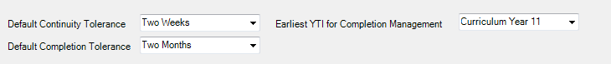
IMPORTANT NOTE: Courses for students in Year 11 must be ended before the 1 August so that they are not confused with qualifications for Year 12 and above.

Completed

Checking Default Completion and Continuity Tolerance
Select Tools | Academic Management | Course Manager | Course Manager Settings to display the Update Course Manager Settings page.
The Default Completion Tolerance field defaults to Two Months. The length of time specified here indicates the period of time prior to the expected course completion date that a student can leave a course and still be deemed to have completed the course. For example: If a student completes the course and examinations in June, which is before the Planned End Date at the end of July, this is within the Completion Tolerance of two months. Therefore, the completion status is set to Completed.
A default Status is assigned via Curriculum Assignment by Scheme or via the Leavers routine, when a student leaves a course.
The Default Continuity Tolerance field defaults to Two Weeks. This represents the acceptable length of a 'gap' in course membership, including holidays, which is tolerated before course memberships are deemed to have been discontinued.
For example: If the 'gap' is within the Continuity Tolerance, the course memberships are joined up so that there is no break in membership.
If you wish to change either of the default values, click the applicable down arrow then select from the drop-down list.
The specified Continuity Tolerance and Completion Tolerance values are applied globally to all courses but can be modified for individual courses on the Course Details page (Tools | Academic Management | Course Manager | Maintain Course), if required.

Completed

Checking the Default Course Duration and Tolerances by Level
Select Tools | Academic Management | Course Manager | Course Manager Settings to display the Update Course Manager Settings page.
The Default Course Duration and Tolerances by Level grid displays the default settings for all the available Levels.
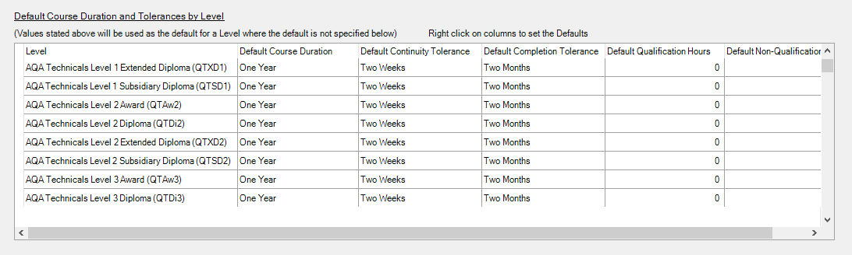
Edits can be made to settings for individual levels, if required.
- Click the applicable cell in the Default Course Duration, Default Continuity Tolerance or Default Completion Tolerance column then select an alternative setting from the drop-down list.
- To reset the level settings back to the default setting, right-click the applicable column heading then click the Set Default as option.
IMPORTANT NOTE: If you want to collectively change the default setting in the Default Course Duration, Default Continuity Tolerance or Default Completion Tolerance column, you must right-click the applicable column heading before saving the data.
If you click the Save button before setting the defaults, the Default Course Duration and Tolerances by Level panel will not correctly reflect the defaults specified in the Settings panel.
- Click the applicable cell in the Default Qualification Hours or Default Non-Qualification Hours column then enter the required number.
When new Levels are added, you are prompted to revisit the default settings to ensure that they are applicable to the new Levels.
It is also suggested that you manually set the Default Course Duration for GCSEs to Two Years in length, i.e. for Years 10 and 11, and then change individual Post 16 courses to 1 year, as appropriate, e.g. Maths GCSE for 6th form is 1 year.
- Click the Save button to apply your changes.

Completed

More Information:
Checking Course Manager Settings on page 8
Checking the Course Duration for an Individual Course on page 33

Starting Next Year's Timetable Early
If you start next year's curriculum early in your school, this will have an impact on class and course memberships. If this year’s student scheme memberships finish at the end of the Summer term, they need to be terminated at the date that the new timetable begins. This should be done to prevent old, as well as new students from appearing in class lists.
Schemes exist for the whole academic year, even if classes and student class memberships within the scheme have end dates before the end of the academic year, unless it was anticipated during the Summer that schemes would finish earlier. If it was not anticipated that the 2022/2023 timetable would finish early and existing memberships need to be adjusted, this should be done before making the new assignments.
Where you want to show students as being in next year's classes, i.e. Year 12 students in Year 13 classes, you should consider the following:
- Class and course memberships for 2022/2023 should finish on the correct date.
- The curriculum plan and timetable should be transferred from Nova for the next academic year.
- Students should be assigned to classes and courses for June/July.
If an early commencement of the next year's timetable results in an early start to courses, the affected courses should be recorded as such in Course Manager. This ensures that the Learning Aims are collected accurately in the School Census.
For example: If Year 11 students finish their exams early then they start their Year 12 course 1 June and continue the course in September, the course will last more than 12 months. It is possible to record the period from the start of the course (in this example June) to the start of the new academic year (September) as an Introductory Session with a level of Other.
Information regarding financial schemes in England to support 16 to 19 year olds can be found on the DfE website (https://www.gov.uk/government/collections/funding-education-for-16-to-19-year-olds).

Additional Resources:
Starting Next Year's Curriculum Early mini guide

Running the Bulk Update Courses Routines
Select Tools | Academic Management | Course Manager | Bulk Update Courses to display the Bulk Update Courses page. This page is separated into two routines:
- Remove August or September End Dates
- Use Completion Tolerance to Reset Status
Both of these routines enable you to retrospectively correct historical data that may have been defined incorrectly.
Before running either Bulk Update routine, it is suggested that you click the associated Report button to view an html report detailing the classes that will be corrected and the changes that will be made.

Running the Remove August End Dates Routine
If schools in England have inadvertently set the end date for classes to a date in August or September, this incorrect date becomes the membership planned end date for courses. This will generate errors in the School Census return. To prevent this becoming an annual problem that requires manual intervention, it is possible to run the Remove August or September End Dates bulk update routine to change the dates to 31 July.
Running the Remove August or September End Dates routine performs the following actions within the parameters of If Start Date is before August and Planned End Date is in August or September:
- Set Planned End Date to 31st July
- If Actual End Date exists set to 31st July
- Adjusts class end dates in line
- If a Status exists, remove it
- Reports on the changes made.
Click the Execute button to run the routine and update the classes.
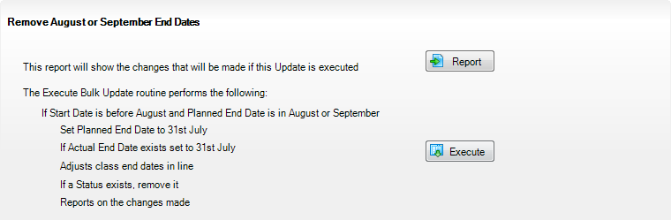
When the process is complete, a report is generated automatically. To view the changes that have been made, compare this report with the report run before updating the classes.

Completed

Running the Using Completion Tolerance to Reset Status Routine
Running the Use Completion Tolerance to Reset Status routine performs the following actions:
- Set Planned End Date to Actual End Date
- Adjusts class end dates in line
- If a Status exists, remove it
- Reports on the changes made.
Click the Execute button to run the routine and update the status for classes.
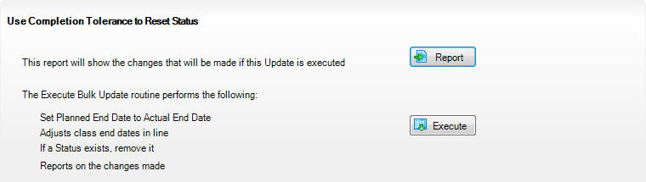
When the process is complete, a report is generated automatically. To view the changes that have been made, compare this report with the report run before updating the status for classes.

Completed

Recording Leavers and Updating Course Memberships
The facility to record leavers enables accurate records to be kept of students after they have left the school. Applicable students, e.g. Year 13, should be marked as leavers as part of the end of year routine.
IMPORTANT NOTES: It is essential that you do not record leavers by removing their date of admission as this affects all historical data relating to that student.
If someone who was a leaver subsequently returns, please ensure that you re-admit them – do not remove their date of leaving because this also affects the history (unless they had a date of leaving, but did not actually leave, i.e. they changed their mind).
To enable the automatic procedures to help you with course completion information for Post 16 students, it is necessary to consider when to make use of the Leavers routine. Some schools will have left the course completion date as the default date when all classes finish. Such a date is not correct for many Post 16 students who will finish the course and leave the school some weeks before the rest of the school finishes for the year. If you make use of the Leavers routine in advance of the students actually leaving, SIMS deals with this problem for you.
The end date for the course will be set in line with this ‘expected’ leaving date and when the School Census is run, the courses will be interpreted as having been completed.
If the Leavers routine is run after the students have actually left, and the course end date was in the future, SIMS updates course membership in accordance with the Completion Tolerance, e.g. if the student's leaving date and the course end date are within the Completion Tolerance, SIMS entered a status of complete.
Update Course Memberships should be run (via Tools | Academic Management | Course Manager | Update Course Memberships) before moving the system to the new academic year and should be run again after moving to the new academic year, once class information is in place. Update Course Membership is an Academic Management routine and like other routines in this area, it is academic year based. If you forget to run Update Course Memberships before moving to the new year, you can easily solve the problem by going back to the old year and running Update Course Membership.
Similarly, if you forget to run Update Course Memberships, as soon as class information is in place, you can run it in the new academic year. However, you should be aware that course membership is much like other group membership, and courses are set active or inactive at the start of the day, depending on what membership they have at the start of the day.
So, if you do not run Update Course Memberships until the actual day of the census, the courses will remain set to inactive until the next day. Active and inactive is only a display parameter, but it could cause unnecessary confusion on census day.
To ensure that information required for the School Census is accurate and up-to-date, it is recommended that you check that all leavers have at least the minimum statutory information recorded before making them a leaver, e.g. ethnicity, first language, etc.

Recording Leavers
- Select Routines | Student | Leavers to display the Find Student(s) browser.
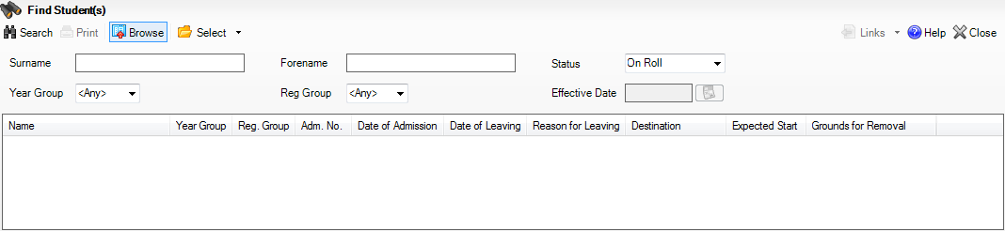
- Search for the required student then double-click their name to display the Manage Student(s) Leaving Details page.
- If you want to assign the status of Leaver to a group of students at once, specify their Year Group or Reg Group then click the Search button. Highlight the required student names by using the Ctrl, Shift and Down Arrow keys then click the Select button. This populates the Students panel with the selected students’ names.
- If you wish to assign the status of Leaver to all the students at once, click the down-arrow on the Select button and choose All. This populates the Students panel with all the students’ names.
- In the Leaving Information panel, enter the student's Date of Leaving or click the Calendar button then select the required date.
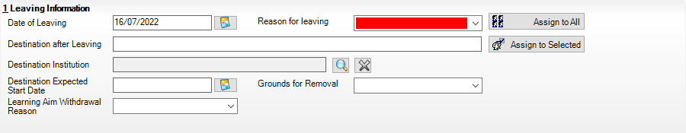
- Select the Reason for leaving from the drop-down list, e.g. Normal leaving age - Higher education institutions.
- Enter the Destination after Leaving, if known.
- Specify the Destination Institution, if known.
- Click the Browse button (adjacent to the Destination Institution field) to display the School Browse dialog.
- Search for and then select the relevant institution. Alternatively, click the New button to add a new institution.
- Click the OK button(s) to return to the Leaving Information panel.
- Use the Assign to All or Assign to Selected options, as required.
- Enter the Destination Expected Start Date (or select the relevant date from the Calendar), then use the Assign to All or Assign to Selected options, as required.
- If the student is a child deemed missing in education, select the Grounds for Removal from the drop-down list, e.g. E - Distance, then use the Assign to All or Assign to Selected options, as applicable.
IMPORTANT NOTE: To comply with the Children Missing in Education legislation, schools are required to record this information for all students on leaving the school.
- Select the Learning Aim Withdrawal Reason from the drop-down list, e.g. Other Provider.
NOTE: The reason for withdrawing from a Learning Aim is collected in the Autumn Return for any Learning Aim with the status of Withdrawn.
- Click the Assign to All button or Assign to Selected button, as applicable.
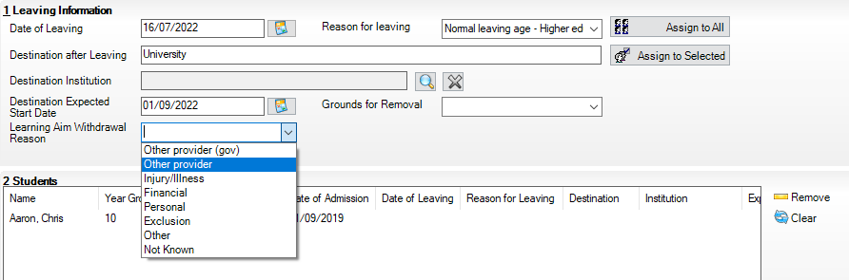
- Click the Save button.
TIPS: To remove a student from the Students list, highlight their record, then click the Remove button.
To correct details enter in error, highlight the applicable student, then click the Clear button. This remove the details drawn from the Leaving Information panel for the selected student only. Re-enter the information as required.
The Learning Aim Reason column remains populated after clicking the Clear button. However, the data is updated automatically if a different reason is selected and assigned.

Additional Resources:
Recording Leavers and Deleting Pupil/Student Records chapter in the Managing Pupil/Students handbook

Completed

Updating Course Memberships
When the Update Course Memberships routine is run outside the Completion Tolerance, if SIMS detects that a course membership is terminating prematurely, the original end date is displayed in the P End Date (planned end date) column in the Members panel on the Course Details page (via Tools | Academic Management | Course Manager | Maintain Course). The completion Status is not populated automatically, because it will not be possible to determine whether the termination should be regarded as withdrawn or transferred. The completion Status must be selected manually. A yellow background indicates that a value has been omitted. When School Census is run, a validation error is generated if the value is missing.
This routine should always be run when any changes to class memberships are made.
- Select Tools | Academic Management | Course Manager | Update Course Memberships to display the following message:
Update course membership can take a long time. Do you wish to proceed?
- Click the Yes button to start the Update Course Membership routine.

Completed

Event Driven Recording of Learning Aims Status
The Earliest YTI for Completion Management also controls the appearance of the New Learning Aims dialog when manually modifying a student membership. For example: if a student drops a class or course the Course Membership(s) dialog is displayed, enabling you to view the suggested completion Status.
- Select Focus | Student | Curriculum Assignment by Student or Focus | School | Academic Structure | Curriculum Assignment by Student to display the Find Student for Curriculum Assignment browser.
- Search for, then select the required student to display the Select Effective Date Range dialog.
- Specify the required date range criteria then click the OK button to display the student's Schemes.
- Right-click on the Scheme that is affected by the change and select Open Details to display the Historical Curriculum Membership Details dialog.
- Drag the orange timeline for the affected class to the required end date and click the OK button.
- Click the Save button on the Student Curriculum Summary page to display the Course Membership(s) dialog.
- Right-click in the Status column and select the appropriate option from the drop-down list:
- if the student's class membership ended within the Completion Tolerance specified for the course, the Status defaults to Completed.
- if the student's class membership ended outside of the Completion Tolerance specified for the course, the Status defaults to Withdrawn and the Learning Aim Withdrawal Reason must be entered.
- if the student has swapped to a different class that is associated with the same course but still within the Completion Tolerance specified for the course, the Status is unaffected.
- if the student transfers to a completely different course, the Status defaults to Transferred.
- Click the OK button to return to the Student Curriculum Summary page.
NOTES: It is possible to extend class memberships within the specified Course Duration only. For example, class memberships cannot continue for two years if the Course Duration is only for one year. If a student’s class membership is amended in Academic Management, their course memberships are updated automatically without the need to run the Update Course Memberships routine manually.

Completed

Checking Core Learning Aims
The School Census Autumn 2023 Return requires that the core aim is identified for each year where a vocational Education and Skills Funding Agency (ESFA) study programme is being followed.
The core aim is the substantive vocational learning aim being undertaken in a student’s program of study.
NOTES: If a student is following an academic programme, a core aim does not need to be identified.
T Level programmes must have the technical qualification as the core aim.
T Level transition programmes will have specific learning aims (prefixed with ZTPR), which will identify the appropriate T level route. This aim will always be the core aim of a transition programme.
It is possible to have a different core aim for 2022/2023 than for 2023/2024. Course Manager allows only one course of study per student to be flagged as a core aim per academic year. If the student is enrolled on a two-year course, you must flag the second year of study as a core aim when the academic year changes.
However, there are certain unusual circumstances where more than one core aim is allowed, e.g. where a student has a two-year course and a one-year course. In the first year their core aim is the one-year course and in the second year their core aim is the second year of the two-year course.
first year of a two-year course | second year of a two-year course  Core Aim
One-year course
Core Aim
The additional core aims can be entered directly into the Learning Aims panel (via Routines | Statutory Returns | School Census).

Additional Resources:
Managing Courses handbook
The Producing the School Census Autumn 2023 Return handbook (applicable to your school phase)

Editing a Core Learning Aim via the Student Courses Page
- Select Focus | Student | Courses to display the Find Student browser, then Search for the required student.
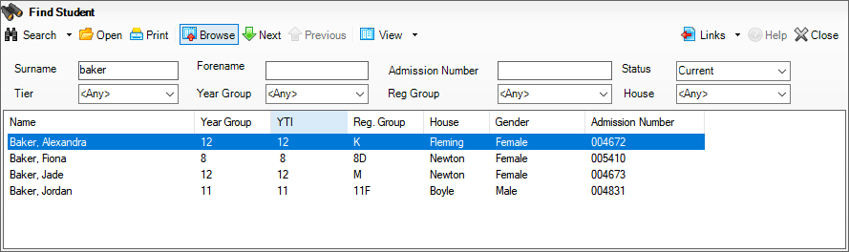
- Highlight the required student, then click the Open button to display the Student Courses page.
- Select Previous Academic Year from the Student Courses drop-down list.
- Highlight the second node of the tree structure, which describes the required course you want to set as a core aim.
- Right-click the highlighted course description then select Set Core Learning Aim from the pop-up menu. Alternatively, click the Set Core Aim button.
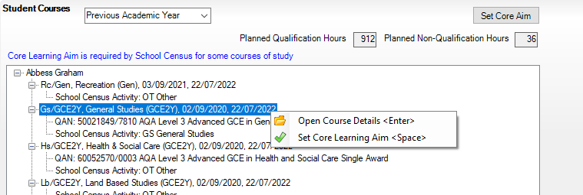
The course description is appended with the text (Core Learning Aim).
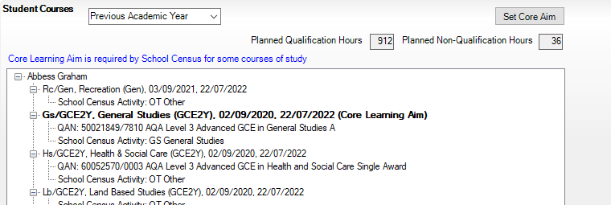
To remove an Existing Core Learning Aim:
If you want to remove the (Core Learning Aim) flag from a course of study, highlight the course details, right-click, then select Unset Core Learning Aim from the pop-up menu.
Alternatively, highlight the details of an alternative course of study, then click the Set Core Aim button. This action removes the Core Learning Aim flag from the original course of study and flags the newly selected course as the (Core Learning Aim).

Completed

Editing a Core Learning Aim via the Memberships and Results Panel
- Select Tools | Academic Management | Course Manager | Maintain Course to display the Find Course browser, then Search for the required course.
IMPORTANT NOTE: Core aims are academic year based, so if the default of Census View is selected in the Find Course browser, the Core Aims column is not displayed. This is because the From and To date range for the Census View spans two academic years.
If you want to view or edit the core aims data in the Memberships and Results panel (Core Aim column), ensure that either Current Academic Year or Previous Academic Year is selected from the View Memberships drop-down list.
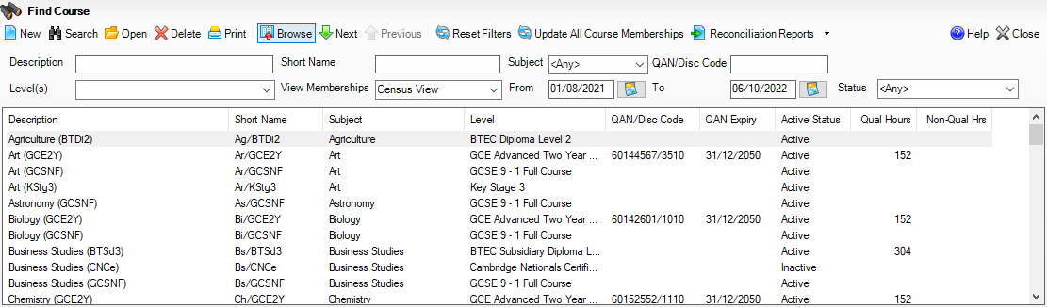
- Highlight the required course, then click the Open button to display the Course Details page.
- Click the Membership and Results hyperlink to display the Membership and Results panel.
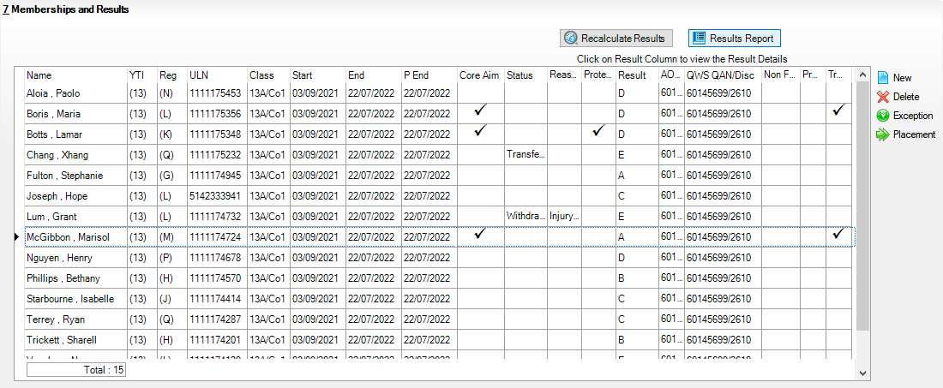
- Indicate which students have this course as their core aim.
- To change the core aim for multiple students, right-click any cell in the Core Aim column then select Set this course as Core Aim for all these students from the pop-up menu.
This assigns the core aim flag to all students in year 12 and above in a single academic year.
- To change the core aim for an individual student, click the required cell in the Core Aim column. A tick is displayed in the cell.
If a core aim already exists for this student in the academic year specified, a warning message is displayed. Click the Yes button to change the core aim or the No button to cancel the process.

To Remove an Existing Core Learning Aim
- In the Core Aim column, click the cell relating to the applicable student's name.
A message warns you that you are removing the core aim for one or more students.
- Click the Yes button to remove the core aim(s) or the No button to cancel the process.

Completed

Preparing Data for the Current Academic Year
Chapter Overview 25
Updating Funding and Monitoring 25
Updating Prior Attainment for 2022/2023 27
Importing Catalogue Files 29
Updating QANs and Discount Codes for Course Manager 31
Checking Course Manager Data for the Current Academic Year 33
Work Placements 44
Maintaining Post 16 Programmes of Study 46
Recording Post 16 Employment Information 52

Chapter Overview
This chapter provides guidance about the tasks that need to be performed to ensure that the Post 16 data for the current academic year is complete and accurate in time for the forthcoming School Census.

Updating Funding and Monitoring
The pupil level Update Funding and Monitoring functionality is provided to enable schools to record aspects of the Education Recovery Package.
From 1 August 2022 schools should record tutoring that was delivered via any of the following National Tutoring Programme (NTP) delivery routes:
- tuition partners
- academic mentors
- school-led tutoring.
In the previous academic year school-led tutoring only was collected.
More information about the National Tutoring Programme is available on the GOV.UK website https://www.gov.uk/government/publications/national-tutoring-programme-ntp.
The information can be recorded via the Tools menu and maintained at any time during the academic year.
The information required is based on individual students:
- Student in receipt of tutoring programme: Applicable to all schools (except Nursery schools), with the appropriate year groups or age groups, i.e. pre-16. For students in National Curriculum Year Actual 1 to 11, or aged 5 to 15 as at 31/08/2022 in National Curriculum Year Actual ‘X’ for special schools. (Funding and Monitoring code = 01.)
- Student in receipt of 16 to 19 tuition fund: Applicable to Secondary, All-Through and Pupil Referral Units or Alternative Provision schools with a sixth form. For students in National Curriculum Year Actual 12 and above with current single registration (C) or current main dual registration (M). Pupil Referral Units or Alternative Provision for any student with the following enrolment status: C, M, F or O. (Funding and Monitoring code = 21.)
- Student repeating up to one full year of 16 to 19 funded provision: Applicable to Secondary, All-Through and Pupil Referral Units or Alternative Provision schools with a sixth form. For students in National Curriculum Year Actual 12 and above with current single registration (C) or current main dual registration (M). Pupil Referral Units or Alternative Provision for any student with the following enrolment status: C, M, F or O. (Funding and Monitoring code = 22.)
- Select Tools | Statutory Return Tools | Update Funding and Monitoring to display the Update Funding and Monitoring page.
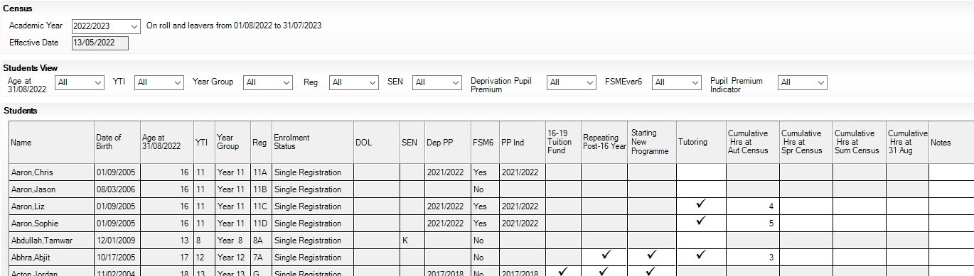
The 2022/2023 Academic Year is displayed for on-roll students and leavers from 01/08/2022 to 31/07/2023.
Read-only Student information is displayed in the columns on the left-hand side of the panel. This information is displayed as at the system date.
Cells with a white background are editable.
- In the Students View panel, select 16+ from the Age at drop-down list.
In addition, a variety of other filters can be specified, if required.
The contents of the Students panel changes to reflect the options selected.
- Right-click anywhere in the 16-19 Tuition Fund column, then select the required option from the pop-up menu.
If most or all of the students have been receiving tuition funding, select the Check All option.
Any students who have not been receiving school-led tutoring can then be deselected by clicking the 16-19 Tuition Fund cell adjacent to their name.
- Specify which students are Repeating Post-16 Year by right-clicking anywhere in the column, then selecting the required option from the pop-up menu.
Bulk or Individual entry can be achieved using the same method as described for 16-19 tuition funding.
Where Repeating Post-16 Year has been ticked for a Year 13 and above student, a completed programme and an additional continuing programme is reported.
If a Year 12 student is repeating their Post 16 year, the Starting New Programme column is activated.
- Specify which Year 12 students are Starting New Programme by right-clicking anywhere in the column, then selecting the required option from the pop-up menu.
Where Repeating Post-16 Year has been ticked for a Year 12 student and Starting New Programme has also been ticked, the XML return file will report a completed programme and an additional continuing programme.
Where Repeating Post-16 Year has been ticked for a Year 12 student and Starting New Programme is not ticked, a continuing programme is reported.
- Enter Notes, if required. This information is for your school's use and is not collected in the census.
- Click the Save button and then click OK to return to the Census Return Details page.
IMPORTANT NOTE: All validation errors (red cells) must the resolved before saving the data.
DfE guidance about Learner funding and monitoring (FAM) is available on the GOV.UK website (https://www.gov.uk/guidance/complete-the-school-census/data-items-2022-to-2023).
More Information:
Post-16 Funding and Monitoring Report on page 60
Additional Resources:
Producing the School Census Autumn 2023 Return handbook

Completed

Updating Prior Attainment for 2022/2023
The following 2022/2023 information is collected for the Autumn School Census:
- Maths Highest Grade
- Maths Prior Attainment
- Maths Funding Exemption
- English Language or English Language/Literature Highest Grade
- English Language or English Language/Literature Prior Attainment
- English Language or English Language/Literature Funding Exemption.
The Update Prior Attainment page displays information about students who are in or were in year taught in 12+ (01/08/2021 to 05/10/2022).
The Effective Date displays the 2022 Autumn census date. This field is read-only.
- Select Tools | Statutory Return Tools | Update Prior Attainment to display the Update Prior Attainment page.
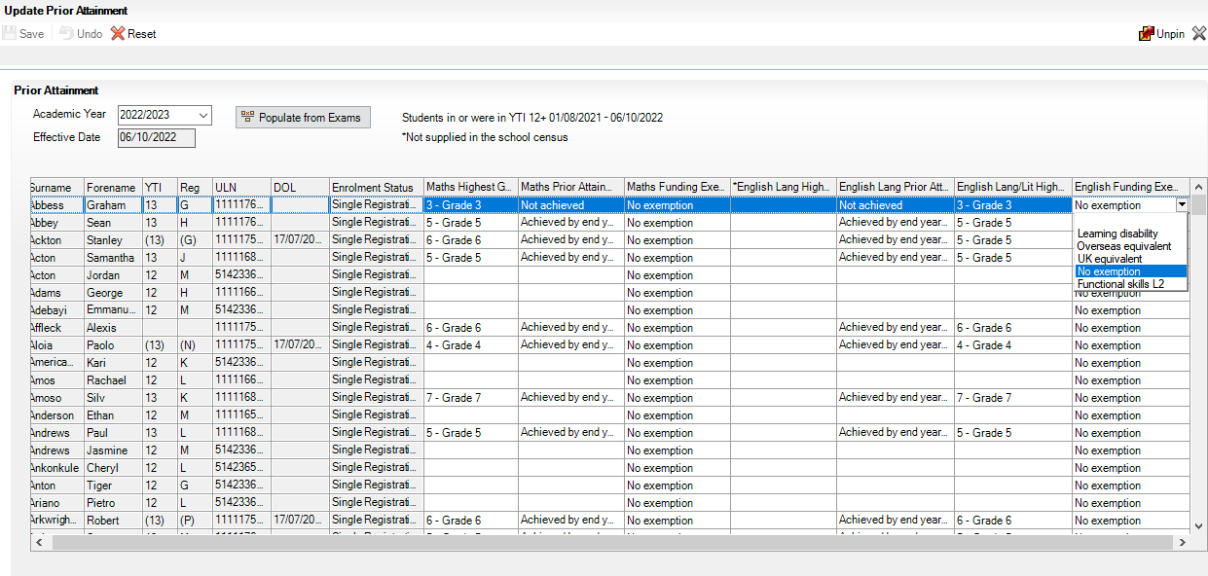
- Ensure that the 2022/2023 is selected from the Academic Year drop-down list.
- Click the Populate from Exams button to display the Update Prior Attainment dialog.
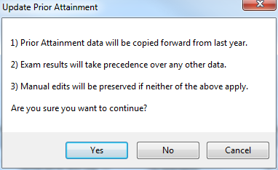
- If you want to continue, click the Yes button to populate/update the Prior Attainment grid.
- Prior attainment data is then copied forward from last year.
- Exam results take precedence over any other data.
- Manual edits are preserved if neither of the two previous points apply.
- The Populate Data From Exams dialog confirms that data has been populated from Exams. Click the OK button.
- Edit the information, if required.
- Click the Save button.
The Update Prior Attainment page for 2022/2023 displays the following:
- English Language Highest Grade is displayed to show the relationship with English Language Prior Attainment (but is not included in the return).
- English Lang/Lit Highest Grade is displayed showing the relationship to English Funding Exemption.
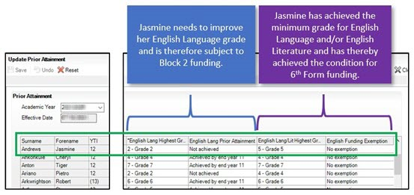
The DfE uses the English GCSE Prior Attainment achievement values of Achieved by end of year 11, Achieved since year 11 and Not achieved for what they refer to as 'block 2' funding. However, for the purposes of this funding, achievement of prior attainment in English must be taken to mean achievement of English Language GCSE prior attainment; it must not take account of English Literature GCSE. Therefore, the DfE has changed its CBDS (Common Basic Data Set) for this item to refer to English Language rather than English.
The DfE has pointed out that both English Language and English Literature remain relevant for the 'condition of funding' (https://www.gov.uk/guidance/16-to-19-funding-maths-and-english-condition-of-funding).

More Information:
Correcting 2022/2023 Prior Attainment for Resubmitting in the Autumn Census on page 7

Importing Catalogue Files
It is recommended that the DfE Qualification Data catalogue is downloaded from the DfE QAN website (https://collectdata.education.gov.uk/qwsweb/default.aspx) and imported into SIMS in September (when the courses are being set up) and before starting the School Census Autumn 2023 Return (05/10/2022).
The qualification data is applicable to all Learning Aims without a result or basedata supplied by the exam Awarding Organisation or Body including new courses and completed school assessed Learning Aims.
- Download the latest Generic QAN data files from the DfE QAN website to a folder of your choice. The following four files only are required:
- Current QAN XML
- Discount Codes XML
- Awarding Bodies XML
- Qualification Types XML.
- In SIMS, select Tools | Examinations | Import Qualification Data. A confirmation dialog is displayed.
- Click the OK button to confirm that the downloaded data you are about to import is up-to-date. The Import Qualification Data page is displayed.
- In the Select Catalogue Files panel, click the Browser button adjacent to each file name field then navigate to the stored location of the applicable file.
- Select the required XML file then click the Open button to return to the Select Catalogue Files panel where the selected file name is displayed.
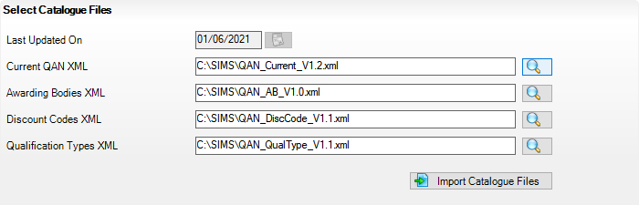
- Click the Import Catalogue Files button.
Provided that you have selected the correct file name for each file type, the files are automatically imported in the correct order. This may take some time.
When the files have imported successfully, an Activity Log is displayed confirming which files have been imported.
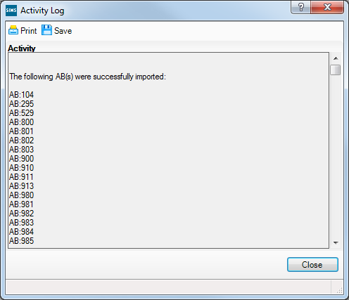
- Click the Close button to return to the Import Qualification Data page.
- You can click the Print button to print a copy of the file names and locations for future reference.
When you next open the Import Qualification Data page, the Last Updated On field displays the date of the most recent import.

Completed

Updating QANs and Discount Codes for Course Manager
Once the up to date QWS QAN catalogues have been imported into Course Manager, specific QANs and QAN Discount Codes must be activated to ensure that they are available for selection.
- Select Tools | Academic Management | Course Manager | Update QANs and Discount Codes for Course Manager to display the Update QANs and Discount Codes for Course Manager page.
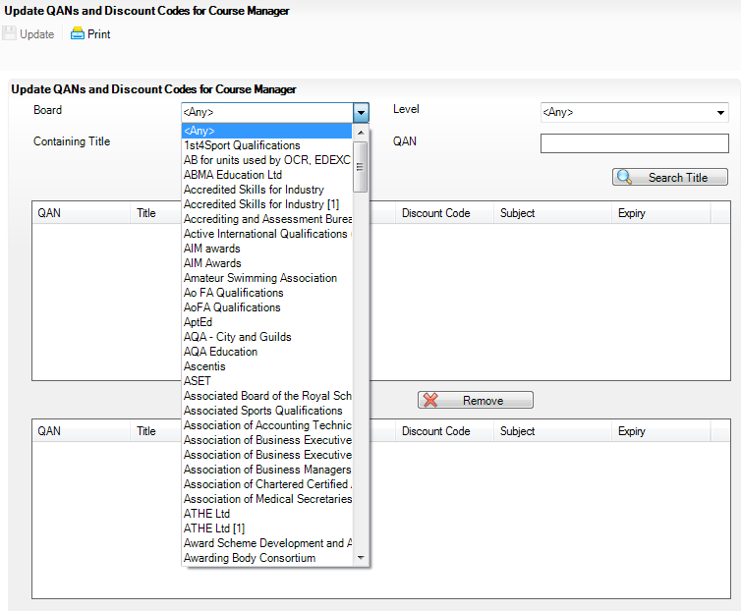
- Specify the QAN search criteria by selecting from the Board and Level drop-down lists. Alternatively, enter all or part of the QAN’s Containing Title or QAN code.
- Click the Search Title button.
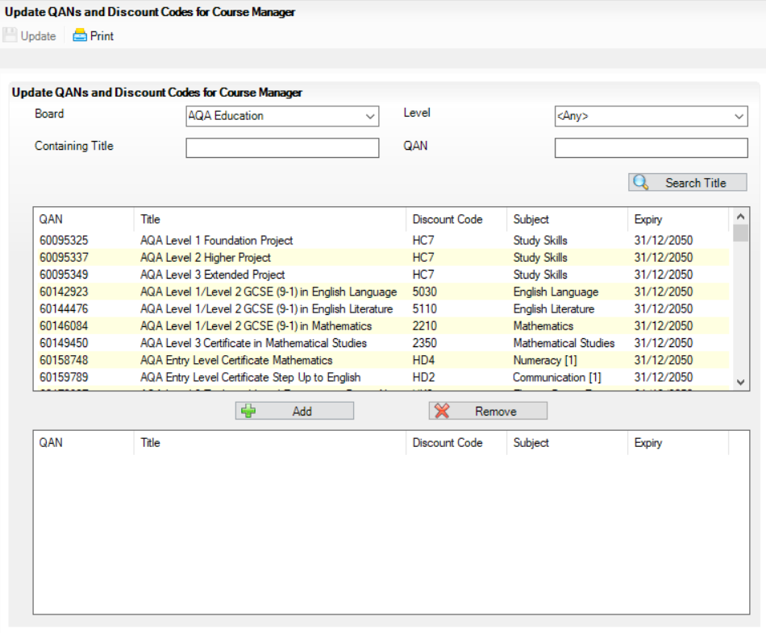
- Highlight the required QANs, then click the Add button to move the selected item to the lower panel.
- If an item is selected by mistake, highlight it, then click the Remove button.
- When you have selected all the required QANs, click the Update button.
These items will now be available for use within Course Manager.
NOTE: If items are already available for selection within Course Manager, they are not visible when searching the QAN and Discount Codes catalogue.
The Duplicate QAN report, which displays information regarding students who have a Learning Aim with a status of transferred, withdrawn, completed or continuing, is available by selecting Tools | Academic Management | Course Manager | Duplicate QAN Report. For more information, please refer to the Managing Courses handbook.

Checking Course Manager Data for the Current Academic Year
- Select Tools | Academic Management | Course Manager | Maintain Course to display the Find Course browser.
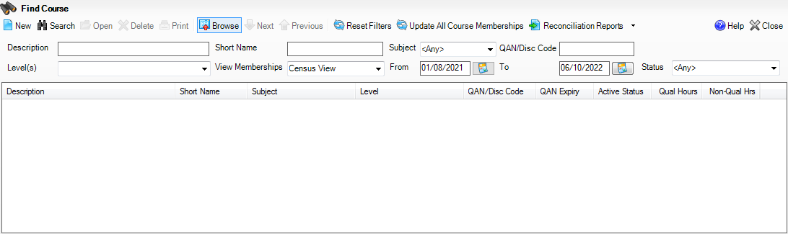
- Search for, then select the required course to display the Course Details page.

Checking the Course Duration for an Individual Course
The values in the Duration and Tolerance panel are inherited from the settings specified in the Update Course Manager Settings page (Tools | Academic Manager | Course Manager | Course Manager Settings). These values can be changed for an individual course by clicking the respective drop-down list and selecting an alternative value. Any changes made are specific to the course that you are currently viewing.
The date range displayed is inherited from the Find Course browser. Select the respective Calendar button to change the dates.
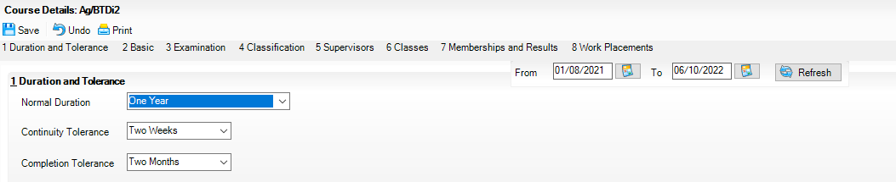
The Course Duration value can be used to determine whether a new class membership should be added to an existing course membership, for the purposes of retakes.
Two-year courses must be set up correctly to ensure that after the completion of year one, the status for students is displayed as Continuing to indicate that a result is not expected until after year two of the course is completed.
The Continuity Tolerance value can be used to decide whether a single student's memberships should be joined to form a continuous course membership.
The Completion Tolerance value enables you to determine if a student leaving their course before the Planned End Date is deemed to have a course completion status of Completed. This is reflected in the Memberships and Results panel of the Course Details page.

Completed

More Information:
Checking Course Manager Settings on page 8
Checking the Default Course Duration and Tolerances by Level on page 12

Checking Examination Award Details
- Select Tools | Academic Management | Course Manager | Maintain Course to display the Find Course browser.
- Search for, then select the required course to display the Course Details page.
- Select the Examination hyperlink to display the Examination panel.
Only one award can be associated with a course at a time, so you must determine which of the awards is current.
- Ensure that each award is applicable for the current season.
This can be achieved by checking the Certification Elements. The Certification Elements panel displays the elements for seasons that are relevant to the highlighted award within the From and To date range. You may need to expand the Season column to view the full season description.
Click anywhere in the certification element row to display the Element Details pane to view all related information about the element.
- Add a To date to any award that was previously associated with the course but is no longer relevant. These awards should not be deleted, as the history will be lost.
If the date ranges for the awards overlap, the records remain displayed in yellow until the overlap is corrected.
- An explanation of why the award associated with the exam was changed can be entered in the Reason column, if required.
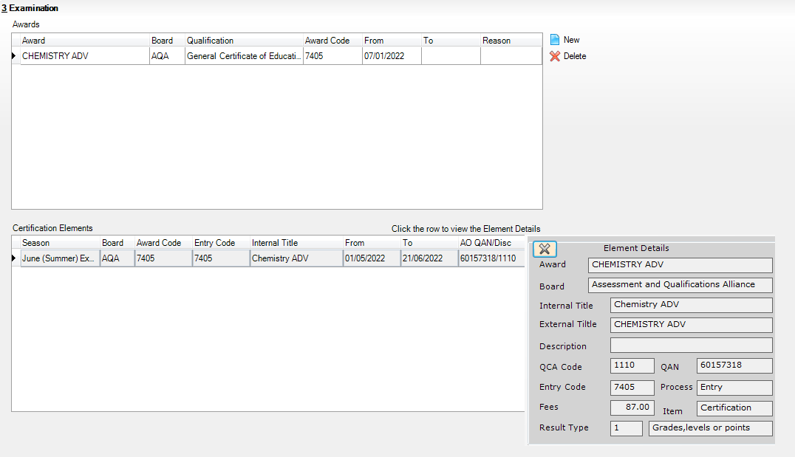
WARNING: Although it is possible to delete awards, it should be noted that the history will be lost.

Completed

Selecting Additional Attributes for a Course
The following codesets are available:
- QCA (Qualification Curriculum Authority)
- QAN (Qualification Number/Discount Code)
- DAS Generic QAN (Diploma Aggregation Service - Generic QAN)
- PPoS (These must be entered manually as there is no pre-defined code list)
- Provider UKPRN (These must be entered manually as there is no pre-defined code list).
- Select Tools | Academic Management | Course Manager | Maintain Course to display the Find Course browser.
- Search for, then select the required course to display the Course Details page.
- Select the Classification hyperlink to display the Classification panel.
- Select the appropriate date range for each codeset. If the date ranges for the codesets overlap, the dates must be changed to rectify this.
- The optional Reason field enables you to enter a free text explanation of why the codeset associated with the course was changed.
- If the codeset(s) displayed is not currently linked to the course, click the New button to display the Select Code dialog.
- Highlight the required codeset to display a list of related codes in the lower section of the dialog.
- Search for the required code by entering the code number in the Containing Code field or by entering some related text in the Containing Description field before clicking the Go button. The list of related codes displayed is updated to reflect the search criteria entered.
- Highlight the Code to be associated with the course then click the OK button to return to the Classification panel where the 'old' and 'new' codesets are displayed.
- Ensure that a To date is entered for the 'old' codeset.
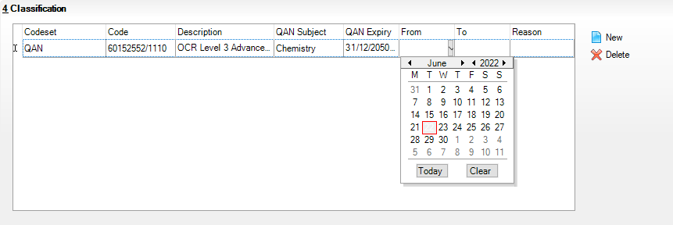
If a code has been added in error, or you wish to change the code associated with the selected course, highlight the existing code and click the Delete button.
IMPORTANT NOTE: Deleting a code should be performed with caution. For example, removing a code from an active course has serious implications for the School Census.
- Repeat Steps 1-4 to add a different code.

Completed

Checking Membership and Results
The QWS QAN is the Qualification Accreditation Number obtained from the DfE QAN website and the AO QAN is the Awarding Organisation QAN imported with the exams basedata from the Awarding Organisation.
If the option to use Examinations Organiser to populate the census is selected and a result exists, the AO Discount Code is collected in the return. If this is not the case, the QWS Discount Code is collected.
- Select Tools | Academic Management | Course Manager | Maintain Course to display the Find Course browser.
- Search for, then select the required course to display the Course Details page.
- Click the Memberships and Results hyperlink to display the Memberships and Results panel.
The details of all the student memberships for the selected course are displayed.
NOTE: If you want to view or edit the core aims data in the Memberships and Results panel (Core Aim column), you must ensure that you select either the Current Academic Year or the Previous Academic Year from the View Memberships drop-down list in the Find Course browser.
If you wish to protect a particular student's membership from changes, ensure that you click the applicable cell in the Protect column before you click the Update All Course Memberships button on the Find Course browser.
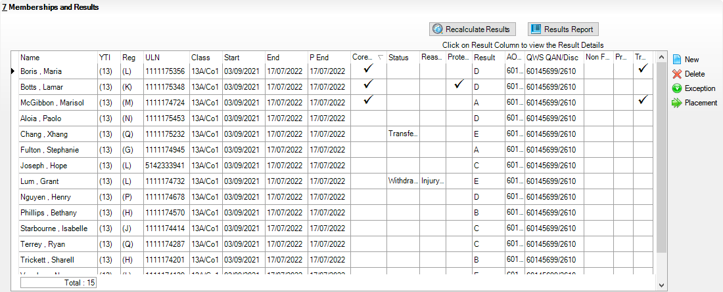
- Check the current status of each Learning Aim, i.e. Completed, Continuing, Withdrawn and Transferred. A yellow cell indicates that the Learning Aims status should be added.
Right-click the Status column then select the appropriate option from the drop-down list:
- if the student's class membership ended within the Completion Tolerance specified for the course, select a status of Completed.
- if the student's class membership ended outside of the Completion Tolerance specified for the course, e.g. because they left the school or they are concentrating their time on other course subjects, select a status of Withdrawn.
- if the student has swapped to a different class that is associated with the same course but still within the Completion Tolerance specified for the course, the status should remain the same.
- if the student transfers to a completely different course, select a status of Transferred.
- Select the withdrawal Reason from the drop-down list to record why the student is leaving a course or learning aim before the expected end date.
- Where the provider of a course is other than the school, e.g. the school sub-contracts the learning or training for post-16 students to another provider, click the required cell and then select the applicable Provider UKPRN (United Kingdom Provider Reference Number) from the drop-down list.
- Click the Save button.

Completed

More Information:
Recording Leavers on page 16

Indicating Traineeships
A traineeship is an education and training programme with work experience. Traineeships (designed for 16 to 24 year olds) include the work preparation training, English and/or Maths and the work experience needed to secure an apprenticeship or employment.
In preparation for the Autumn census, ensure that traineeships are indicated, where applicable.
- Select Tools | Academic Management | Course Manager | Maintain Course to display the Find Course browser.
- Search for, then select the required course to display the Course Details page.
- Click the Memberships and Results hyperlink to display the Memberships and Results panel.
This panel displays the details of all student memberships for the selected course.
- If a student is participating in a traineeship programme, ensure that this is indicated by clicking the Traineeship column (located at the right-hand side of the panel) to display a tick.
- Click the Save button.

Setting up Courses for T Level
T Level courses include the following compulsory elements:
- A technical qualification includes:
- Core theory, concepts and skills for an industry area (e.g. Design, Surveying and Planning for Construction)
- Specialist skills and knowledge for an occupation or career (e.g. Occupational Specialism could be Civil engineering)
- An industry placement with an employer
- A minimum standard in Maths and English if students have not already achieved them.
- Industry placements:
- Every T Level includes an industry placement with an employer focused on developing the practical and technical skills required for the occupation.
These courses last a minimum of 315 hours (approximately 45 days) but can last longer. Employers can offer industry placements as a block, day release or a mix of these.
A course can be set up as a T Level (Level 3) for a specific T Level subject. There is a specific QN code for each core T Level and T Level Occupational Specialism.
The following example shows a course for T Level with a core Subject of Digital Design and a QN of 60358324/TQ06.
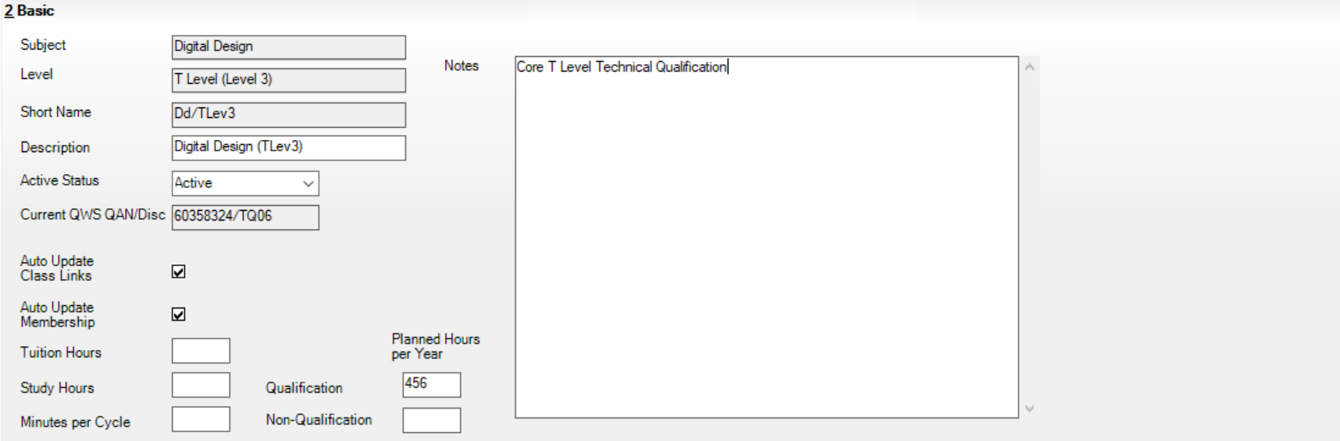
The QAN can be assigned in the Classification panel, as shown in the following graphic.
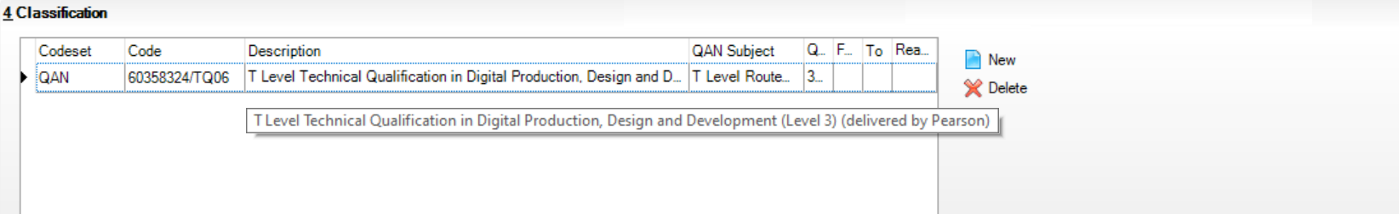
The following graphic displays an example of the Membership and Results panel, where the student membership lasts for two years and the core T Level course is identified as the Core Aim.
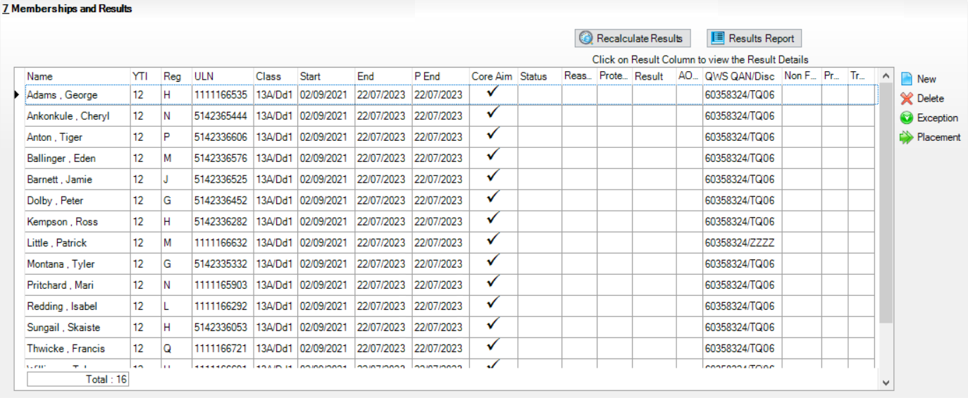
The following graphic displays some of the T Levels associated with the QN. New QNs are available for T Levels and T Level Occupational Specialism.
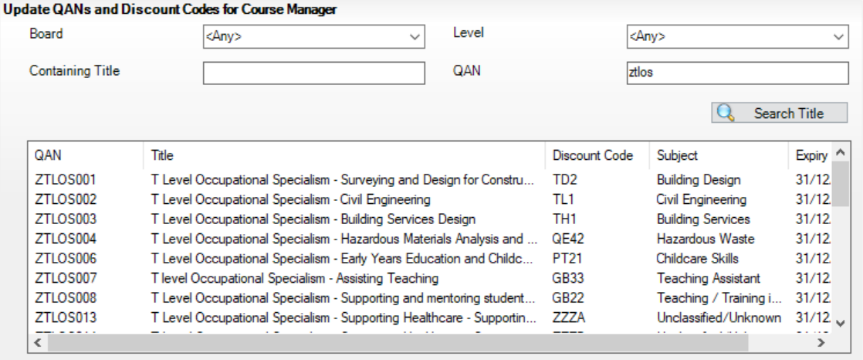
For more information, please refer to the following DfE websites:
- Introduction of T Levels (https://www.gov.uk/government/publications/introduction-of-t-levels/introduction-of-t-levels)
- How to record T Levels (https://www.gov.uk/government/publications/t-level-funding/record-your-t-level-data-correctly).

QNs and Discount Codes
Schools must record the new QN reference for students starting Occupational Specialisms from Autumn 2022 onwards. These new QNs all start with ‘ZTLOS’. Schools should continue to use the original QN references for students who started Occupational Specialisms in Autumn 2022 until they complete their courses. These QNs will have an approval end date of 31 July 2023 and a certification end date of 31 July 2024.
The following table shows the relevant QN data from the DfE QWS website and some suggestions on how these could be associated with SIMS levels and subject created in SIMS. Although most of this data is relevant only for those schools that will be providing T level programmes from September 2022, the data on work placements may also be relevant for other types of programme.

QN/Discount Code | Qualification Title | Short Title | Suggested SIMS Level | Suggested SIMS Subject
60358294/TQ07 | T Level Technical Qualification in Education and Childcare (Level 3) (delivered by NCFE) | Education and Childcare | TLev3  T Level (Level 3) | TQ-Educ & C’care
ZTLOS006/PT21 | T Level Occupational Specialism - Early Years Education and Childcare | Early Years Education and Childcare | TLevS  T Level 3 - Specialism | OS-Early Yrs Educ & C’care
ZTLOS007/GB33 | T level Occupational Specialism - Assisting Teaching | Assisting Teaching | TLevS  T Level 3 - Specialism | OS-Assisting Teaching
60358300/TQ04 | T Level Technical Qualification in Design, Surveying and Planning for Construction (Level 3) (delivered by Pearson) | Design, Surveying and Planning for Construction | TLev3  T Level (Level 3) | TQ-DSPC
ZTLOS001/TD2 | T Level Occupational Specialism - Surveying and Design for Construction and the Built Environment | Surveying and Design for Construction and the Built Environment | TLevS  T Level 3 - Specialism | OS-SDCBE
ZTLOS002/TL1 | T Level Occupational Specialism - Civil Engineering | Civil Engineering | TLevS  T Level 3 - Specialism | OS-Civil Engineering
ZTLOS003/TH1 | T Level Occupational Specialism - Building Services Design | Building Services Design | TLevS  T Level 3 - Specialism | OS-BS Design
ZTLOS004/QE42 | T Level Occupational Specialism - Hazardous Materials Analysis and Surveying | Hazardous Materials Analysis and Surveying | TLevS  T Level 3 - Specialism | OS-HMAS
60358324/TQ06 | T Level Technical Qualification in Digital Production, Design and Development (Level 3) (delivered by Pearson) | Digital Production, Design and Development | TLev3  T Level (Level 3) | TQ-Digital Prod D&D
ZTLOS005/KA4 | T Level Occupational Specialism - Digital Production, Design and Development | Digital Production, Design and Development | TLevS  T Level 3 - Specialism | OS-Digital Prod D&D
ZWRKX001 | 16-19 Study Programme – Work Experience/Placement | 16-19 Study Programme Placement |  | WP/WE - P16 Study Prog
ZWRKX002 | CDF – Industry Placement | CDF Industry Placement |  | WP-CDF
ZWRKX003 | T Level – Industry Placement | T Level Industry Placement |  | WP-T Level
ZTPR0001/ZZZZ | Agriculture, Environmental and Animal Care |  | TLevT  T Level Transition
ZTPR0002/ZZZZ | Business and Administration |  | TLevT  T Level Transition
ZTPR0003/ZZZZ | Catering and Hospitality |  | TLevT  T Level Transition
ZTPR0004/ZZZZ | Education and Childcare |  | TLevT  T Level Transition
ZTPR0005/ZZZZ | Construction |  | TLevT  T Level Transition
ZTPR0006/ZZZZ | Creative and Design |  | TLevT  T Level Transition
ZTPR0007/ZZZZ | Digital |  | TLevT  T Level Transition
ZTPR0008/ZZZZ | Engineering and Manufacturing |  | TLevT  T Level Transition
ZTPR0009/ZZZZ | Hair and Beauty |  | TLevT  T Level Transition
ZTPR0010/ZZZZ | Health and Science |  | TLevT  T Level Transition
ZTPR0011/ZZZZ | Legal, Finance and Accounting |  | TLevT  T Level Transition

Setting up Courses for T Level Transition
T Level Transition Programme is a type of 16 to 19 study programme specifically to help students to progress onto a T Level.
T Level transition programmes have specific learning aims (prefixed with ZTPR), which identify the appropriate T level route. This aim will always be the core aim of a transition programme.
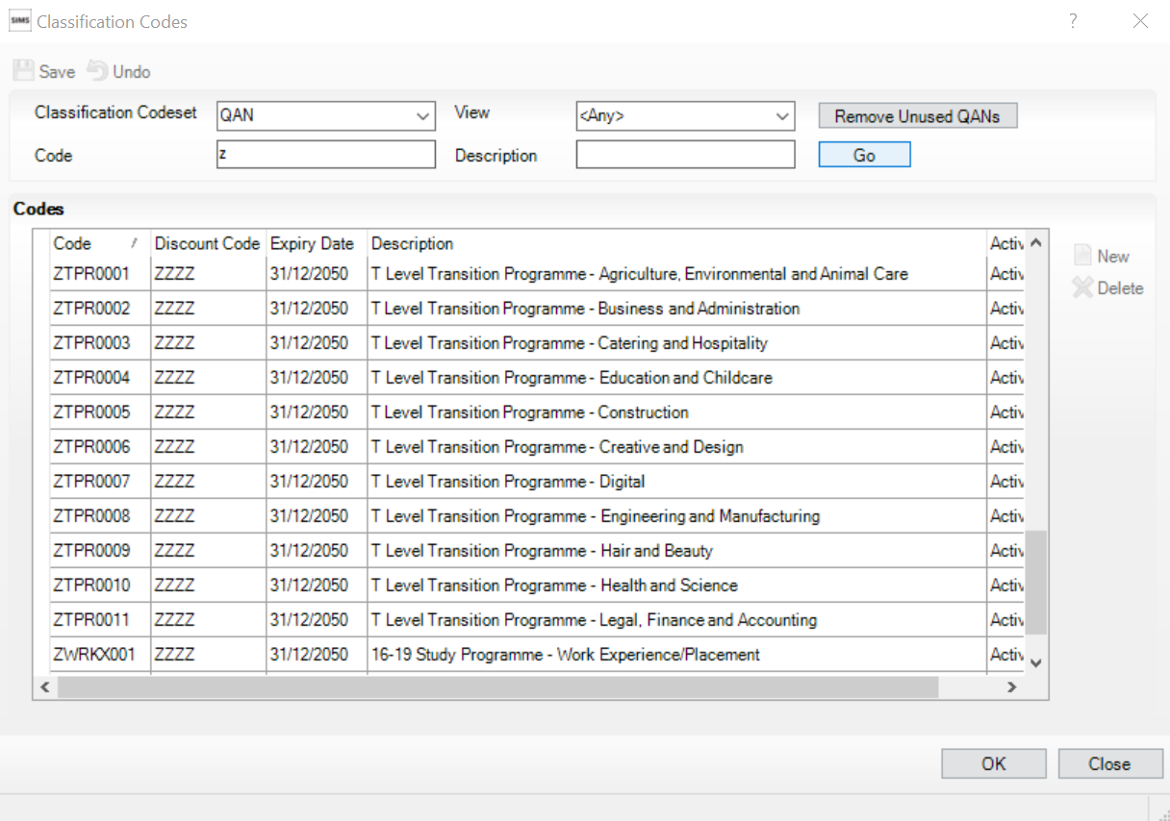
For more information, please visit the DfE website (https://www.gov.uk/government/publications/t-level-transition-programme-framework-for-delivery-2022-to-2023).

Work Placements
A work placement course must be created in order to record Work Placements. The course must have a specific QN code attached for the Information to be reported in the census.
The School Census Autumn Return collects work experience and industry placements using three specific QNs:
- ZWRKX003 – T Level industry placement
- ZWRKX002 – Industry Placement, Capacity and Delivery Fund (CDF)
- ZWRKX001 – 16 to 19 study programme work experience.

Adding the First Work Placement Record for a Student
Adding the first record for one or more students to the Work Placement panel is achieved via the Membership panel (Tools | Academic Management | Course Manager | Maintain Course) by selecting one or more students and clicking the Placement button.
Once this button has been used to add an initial work placement record for a student, subsequent records for that student can be added either from the Membership panel (via the Placement button) or the Work Placement panel itself (via the Add button).
The initial record does not have to be put in place at an individual level because multiple students can be selected, and the initial record created for all of those that have been selected.
When you select a group of students from the table (shown in the following graphic), clicking the Placement button adds rows in the placement table for all rows selected in the Membership and Results panel.
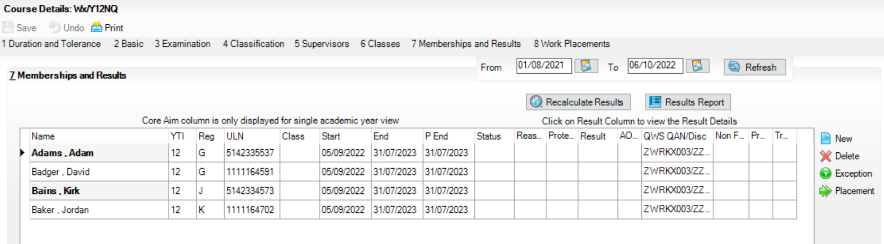
This is an efficient and safer method of completing this task because groups often start their placements at the same time, and it could be used for second (and subsequent) records where this is true for multiple students.

Finding your way Around the Work Placement Panel
Tools | Academic Management | Course Manager | Maintain Course
The Post 16 Learning Aims are collected once a year only, in the School Census Autumn Return. Learning Aims are collected from the previous year, i.e. any that were active in 2022/2023, and those for the current academic year 2022/2023.
The School Census Autumn Return collects work experience and industry placements using three specific QNs:
- ZWRKX003 – T Level industry placement
- ZWRKX002 – Industry Placement, Capacity and Delivery Fund (CDF)
- ZWRKX001 – 16 to 19 study programme work experience.
A work experience/industry placement QN can have more than one work placement.
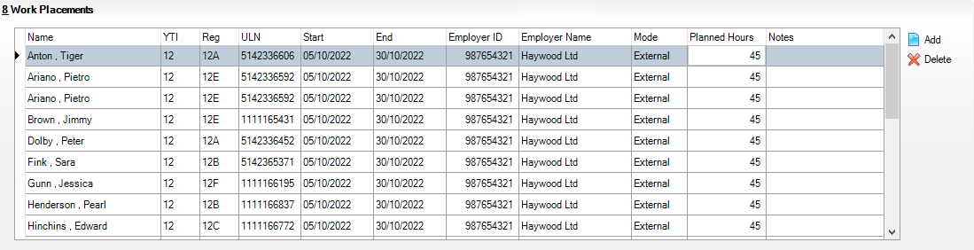
Name, YTI, Reg and ULN: Identification of the student for the placement.
Start: Start date for the placement. This should be a date within the student’s membership of the course.
End: End date for the placement. This should be a date within the student’s membership of the course.
Employment ID and Employer Name: Identification of the employer for the placement. Only the ID is included in the census. Use the employer reference number (ERN) from the Employer Data Service (https://edrs.education.gov.uk/search/lsc/find.aspx).
Mode: Whether the placement is external or internal.
NOTES: This is not included in the census but can be useful for identifying any special aspects of the placement, e.g. the employer might not be able to go ahead with the placement (https://www.gov.uk/guidance/industry-placements).

Maintaining Post 16 Programmes of Study
Every programme must have a programme aim (ZPROG001) spanning the entire duration of the programme. A Programme can span more than one year.
SIMS populates the School Census automatically with the programme aim QN of ZPROG001 where programme information is recorded in Post-16 Programmes of Study (via Tools | Academic Management | Course Manager | Post-16 Programmes of Study). This can be seen in the Post-16 Programmes of Study Detail Report after the Create and Validate process is run.
There are three programme types:
- Study Programme
- T Level Transition
- T Level.
T Levels are a two-year programme and the planned hours must be recorded for the two years (https://www.gov.uk/guidance/16-to-19-education-funding-guidance).
The planned hours recorded for T Levels must include:
- the technical qualification
- specialist content
- non-qualification activity.
The planned hours recorded for T Levels must not include:
- maths and English study
- industry placements
- other qualifications that are not required for completion of the T Level.
The annual hours that count towards a course of study are categorised as:
- Qualification - Planned Learning Hours
or
- Non-Qualification Hours - Planned Employment, Enrichment and Pastoral Hours.
To qualify for funding purposes, Planned Hours must be timetabled within your school's normal working pattern.
More information can be found on the DfE website (https://www.gov.uk/guidance/16-to-19-funding-how-it-works#funding-formula-and-study-programmes).

Calculating Programmes of Study
The list of students displayed on the Maintain Post-16 Programmes of Study page displays all post 16 students, including leavers who have an active course membership in the current academic year and/or the previous academic year. All students who could be included in the School Census Autumn 2022 Return are displayed, whether they are studying at year 1 or year 2 of their programme, or have completed their programme of study and left the school in the previous academic year.
Guidance has been added in bold lettering to the top of the grid to reflect this, e.g. Students with learning aims 01/08/2022 to 31/07/2023.
The content of the Core Aim and Other Courses columns include learning aims that span the date range for the current academic year and the previous academic year.
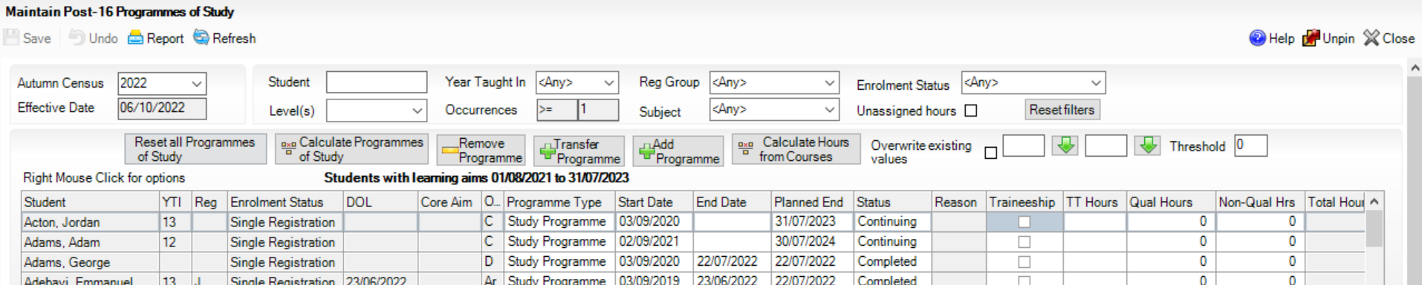
- Right-click any column header, then select Select All from the pop-up menu. Alternatively, select one or more students as required.
- Click the Calculate Programmes of Study button.
A warning message is displayed:
This process will calculate programmes based on learning aims for the selected students.
Existing programme values will not be overwritten.
- Click the OK button to confirm that you wish to continue.
Calculated items are displayed in bold until the changes are saved.

Completed

Recording Planned Hours
Information relating to Programmes of Study for Post 16 student can be recorded, enabling you to submit details of the total Planned Qualification Hours and Planned Non-Qualification Hours in the Autumn School Census.
Planned hours are required for the current academic year and the previous academic year.
- Select Tools | Academic Management | Course Manager | Post-16 Programmes of Study to display the Maintain Post-16 Programmes of Study page.
- Select the required year from the Autumn Census drop-down list, if required.
- The Effective Date field defaults to the date of the Autumn School Census selected. This field is read-only.
- To update the information displayed on the Maintain Post-16 Programmes of Study page to reflect the students and the courses they are undertaking, click the Refresh button.
All students who could potentially be included in the census, i.e. Year 12 + (including Guests and dual subsidiary student), are displayed.
- You can also choose to display only those students with Unassigned hours by selecting the check box. This enables you to identify students assigned to courses who need to have the Planned Hours per Year section completed on the Course Details page. If a value of zero has been entered into either of the columns, this value is treated as a blank allocation of hours and is displayed when the Unassigned hours check box is selected.
The Reset Filters button enables you to restore the default settings.
- Where you have entered the Planned Hours per Year for each individual course of study on the Course Details page, these totals are carried through into the Qual Hours and Non-Qual Hours columns of the Maintain Post-16 Programmes of Study page when you click the Calculate hours from courses button.
- Right-click a student's name to display a pop-up menu. You can access their Student Details page, their Student Courses page or Select All the students from this menu.
The TT Hours (timetabled hours per week) column enables you to check the accuracy of Planned Hours for a timetabled programme of study.
- If you want to manually amend the totals for a specific student, highlight their name in the list, click into the Qual Hours or the Non-Qual Hours column(s) and enter a different total.
- If you want to manually amend the totals for all the students at once, right-click anywhere in the list, press Ctrl & A to Select All the students in the list and enter a different total in the Qual Hours or the Non-Qual Hours column(s). Alternatively, enter a figure in the box adjacent to the green arrow button at the top of either the Qual Hours or the Non-Qual Hours column(s) to flood fill the entire column with the figure entered. You can also enter a figure in the Threshold box, enabling you to check that a student's full-time funding is accurate before it is included in the School Census Return.
The combined hours for each student and their Post 16 Programmes of Study are displayed in the Total Hours column. The figure displayed in this column will be shown with a yellow background to indicate that the figure is less than the figure you specified in the Threshold box.
You can also enter a brief set of Notes to indicate the reason for the manually assigned hours. This will enable you to reconcile and validate your School Census return in conjunction with the Programmes of Study Report, accessible from Routines | Statutory Returns | School Census.
- If you want to determine the total Qual Hours and Non-Qual Hours figures for a student, for all the courses that they are assigned to, based on the information entered on the Course Details page, click the Calculate hours from courses button. Calculate hours from courses does not include hours from courses which are non-funded (i.e. where Non Funded is selected in the Membership and Results panel).
IMPORTANT NOTE: Where non-funded memberships have been indicated (via Tools | Academic Management | Course Manager | Maintain Course), the calculation of hours from courses, in Maintain Programmes of Study, excludes the course hours for those memberships.
Funded memberships, e.g. Maths or English that are being studied as a result of lack of Prior Attainment, are included in the calculated hours from courses. Ensure that these memberships are not marked as Non Funded.
If you have selected the Overwrite existing values check box before clicking the Calculate hours from courses button, the following warning message is displayed:
This process will calculate the planned hours from the courses for the selected students.
Warning: all existing values will be overwritten.
- Click the OK button to continue or click the Cancel button to abandon the process.
- If you want to preserve any existing figures that are present in the Qual Hours and Non-Qual Hours columns, ensure that the Overwrite existing values check box is not selected before you click the Calculate hours from courses button. A following message is displayed:
This process will calculate the planned hours from the courses for the selected students.
- Click the OK button to collate all the Qualification and Non-Qualification totals that have been specified in the Planned Hours per Year section of the Course Details page for each course, and populate the respective columns with the cumulative total for each student according to the courses that they are assigned to. Alternatively, click the Cancel button to abandon the process.
- Click the Save button.
- Click the Report button to print the Maintain Post-16 Programmes of Study page in .html output.

Completed

What features are available to facilitate the completion of the Maintain Post-16 Programmes of Study page?
The following functionality has been provided on the Maintain Post-16 Programmes of Study page, which facilitates the manual entry of programme types and their dates:
- Filters that help schools to limit the number of rows displayed in the table (e.g. two year GCE A-Level students) are available at the top of the page.
- Sorting the table by column values by clicking a column heading, e.g. programme Start Date.
- Bulk selection of rows and bulk entry values using Ctrl + click and Shift + click.
- Discarding, removing and transferring of learning aim information
- Adding a new programme.

More Information:
Applying Filters to Limit the Number of Rows Displayed on page 50
Sorting the Table by Column Values on page 51
Selecting and Entering Information in Bulk on page 51
Discarding, Removing and Transferring Programme Aim Information on page 52

Applying Filters to Limit the Number of Rows Displayed
The content of the table can be filtered to display information relating to a single level, therefore reducing the amount of information displayed on screen.
Select the required level from the Level(s) drop-down list.
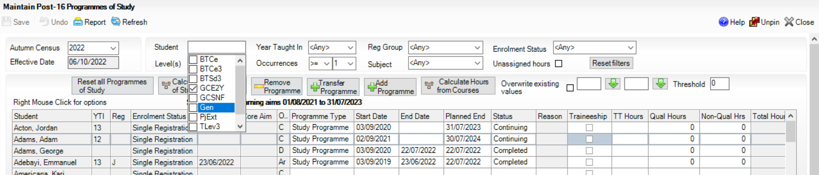
The content of the table then filters to display information relating to the selected level.
It is possible to apply multiple filters to further reduce the content displayed, e.g. you can use a combination of Level(s), Subject, Enrolment Status, etc.

Sorting the Table by Column Values
The display order of the content of the table can be changed. Any filters applied previously are retained.
- Click the Planned End Date column heading. The up arrow is displayed in the column heading, indicating that the content of the table is in ascending date order (i.e. the earliest date is at the top of the list).
- Click the Planned End Date column heading again to change to descending date order (the down arrow is then displayed in the column heading), if required.
The information in the table is then displayed in the selected date order.

Selecting and Entering Information in Bulk
One or more student can be selected enabling single or bulk entry of information. In this example, the Planned End Date for all entries in the table are changed.
- Click the Planned End Date cell of the first person whose date you want to change.
- To select a block of students, hold down the Shift key and click the Planned End Date cell of the last student in the block.
Alternatively, to select multiple students who are not displayed consecutively, hold down the Ctrl key and click Planned End Date cell of the required students.
- Select the required Planned End Date from the Calendar in the drop-down menu of one of the Planned End Date cells.
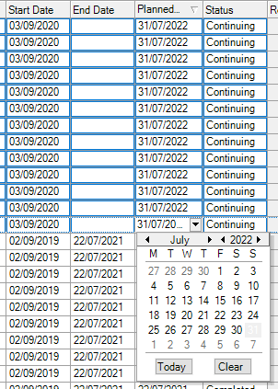

Discarding, Removing and Transferring Programme Aim Information
- Discarding Programme Aim Information
To discard all the programme aim information, click the Reset all Programmes of Study button.
- Removing Programme Information
To remove programme information for selected students, remove their associated programme type.
- Transferring to Another Programme Type
To record a programme as a transfer to another type of programme, click the Transfer Programme button.

Recording Post 16 Employment Information
You should record employment details for Post 16 students whose Year Taught In is 12 or above.
Full-time employed students are those working eight or more weeks consecutively and for 20 or more hours per week, e.g. school hours. Part-time work (e.g. a weekend or evening work) is not included in the full-time employed hours.
- Select Focus | Student | Student Details to display the Find Student browser.
- Search for, then select the required student to display the Student Details page.
- Click the Additional Information hyperlink and then navigate to the Post-16 Employment section at the bottom of the Additional Information panel.
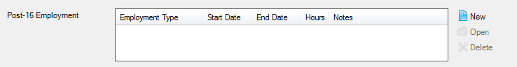
- To add a new employment record, click the New button to display the Add Employment Details dialog.
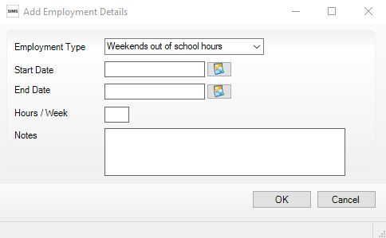
Alternatively, highlight an existing entry then click the Open button to display the Edit Employment Details dialog.
- Select the Employment Type from the drop-down list, i.e. Weekends out of school hours, Weekday(s) out of school hours or School Hours.
- Enter the Start Date of the employment period or click the Calendar button then select the required date.
- Specify the End Date of the employment, if applicable.
- Enter the number of Hours/Week, together with any Notes.
- Click the OK button to return to the Student Details page.
- Click the Save button.

Completed

Additional Information
Managing Performance Indicators 55
Managing Non-EDI Exam Information 56
School Census Autumn 2022 Reports 59
Where Can I Get More Information 60

Managing Performance Indicators
To ensure a smooth transition between the former process of importing the Performance Measures file and the new process of managing performance indicator details in school, the following check list provides an outline of the necessary actions in the order in which they must be undertaken.

Step No. | Action | Location or Menu Route | Complete
Step 1 | Define the new Summer season in Examinations Organiser. | In Examinations Organiser, via Tools | School Setup | Seasons
Step 2 | Download and import the most up-to-date QWS files. | In SIMS, via Tools | Examinations | Import Qualification Data
Step 3 | On the PI Setup page, set the new Summer season as the default PI Summer season and ensure it is unlocked. | In SIMS, via Tools | Examinations | PI Setup
Step 4 | Ensure that the CRD or CKD process has been run for the previous year before cloning QNs. | In SIMS, via Tools | Examinations | Edit PI
Step 5 | Clone the QNs used in the previous year so that they are copied into the new Summer season. | In SIMS, via Tools | Examinations | PI Setup
Step 6 | Search for and delete any QNs that will not be in use this year. | In SIMS, via Tools | Examinations | Manage Performance Indicator
Step 7 | Manually add any additional QNs that will be required for the new season. | In SIMS, via Tools | Examinations | Manage Performance Indicator
Step 8 | Work through the Performance Indicator Details for each QN type and check that the details, point values and entry equivalences are recorded accurately for Key Stage 4 and 16 to 18 year olds for the forthcoming exams season. | In SIMS, via Tools | Examinations | Manage Performance Indicator
Step 9 | Ensure that all qualifications for the 16 to 18 cohort have been assigned to the relevant discount family. | In SIMS, via Tools | Examinations | Manage Performance Indicator

Additional Resources:
Processing Results and Calculating PI Data in Exams and SIMS handbook

Managing Non-EDI Exam Information
The Performance Indicator (PI) routines (now available via the Tools menu in SIMS) assist with the non-electronic data interchange (EDI) results entry.
To ensure that the non-EDI data is displayed in the School Census Learning Aims panel automatically, it must be linked to a course.
- Select Tools | Examinations | Edit PI Data to display a confirmation dialog.
- Confirm that your QWS QN Catalogue is up-to-date by clicking the OK button.
- If PI cohorts exist, you are asked if you want the system to update the PI cohort memberships. Click the Yes or No button, as required.
The Edit PI Data page is displayed.
- Select the check box adjacent to the name of the required candidates.
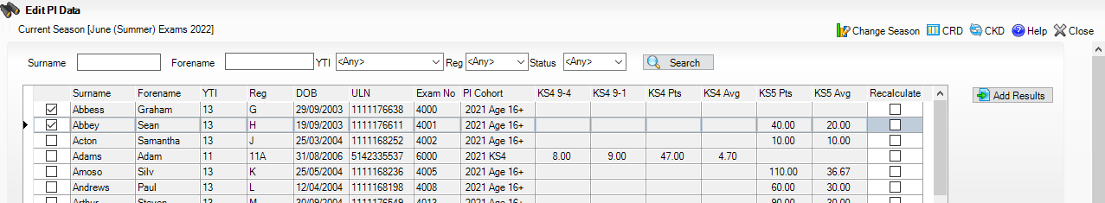
- Click the Add Results button to display the Add Results dialog.
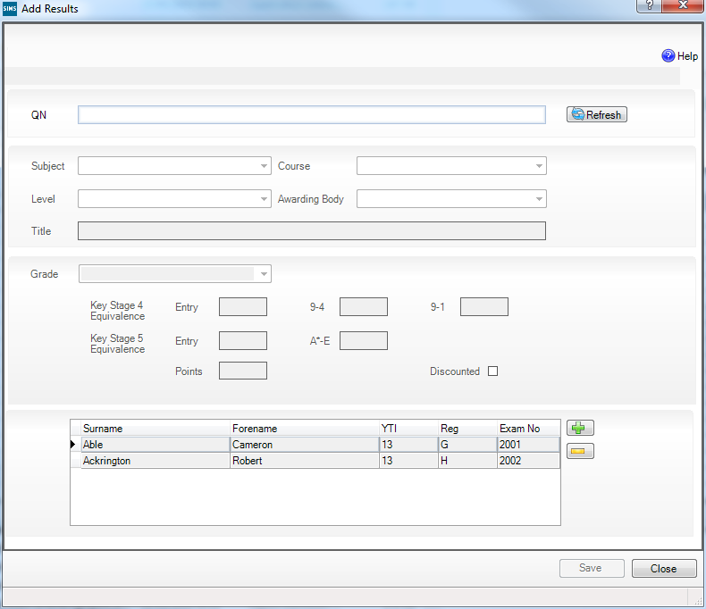
The names of the selected students are displayed in the lower panel, where they can be removed or other students added, if required.
- Enter all or part of the QN code (without slashes) to display a list of examination/courses that match the entry.
- Select the required examination/course to populate the QN field.
- Click the Refresh button to populate the Subject, Level, Awarding Body and exam Title fields automatically.
If the course is already linked to a QN/discount code, the Course field is populated automatically.
The button name changes from Refresh to Change and the QN field changes to read-only.
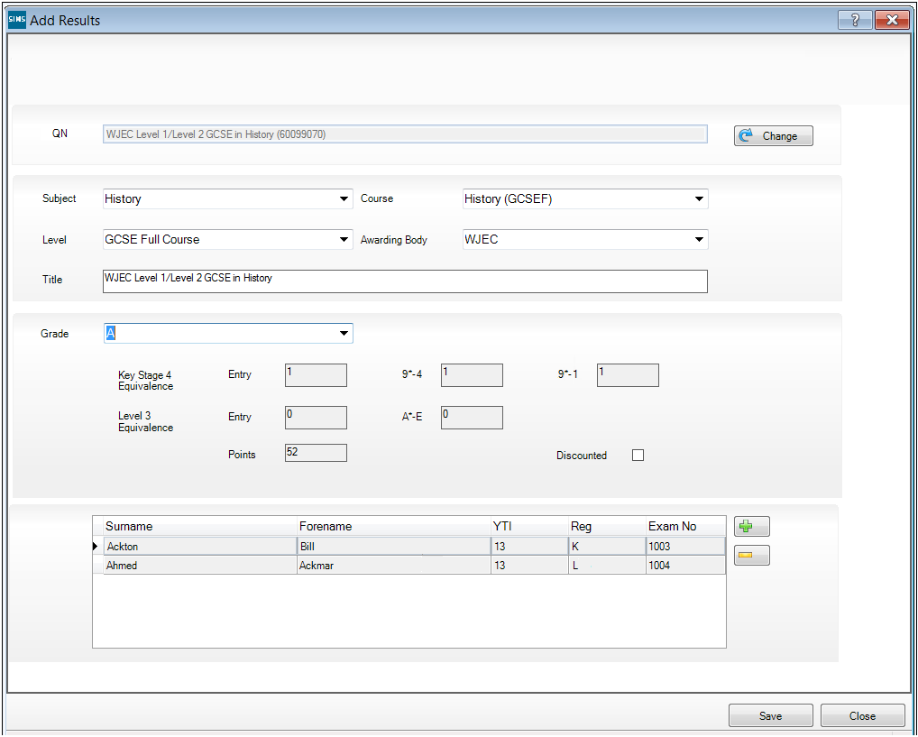
- Select the Grade from the drop-down list. The equivalence entry fields and Points field are populated automatically.
- Select the Discounted check box, if applicable.
- Click the Save button then confirm that the details are correct by clicking the Yes button.
The data is then available to Performance Indicator, Course Manager and School Census.
The results data entered in the Add Results dialog (described in this section) is displayed in the School Census Learning Aims panel when the details are calculated/recalculated via Routines | Statutory Returns | School Census.
WARNING: Clicking the Calculate All Details button overwrites all manual edits.

Additional Resources:
Processing Results and Calculating PI Data in Exams and SIMS handbook

School Census Autumn 2023 Reports
NOTE: The School Census Autumn 2023 Return must be created and validated before the Summary report or any of the detail reports can be run.
The 2023 Autumn return includes the following Post-16 detail reports:
- Post-16 Programmes of Study
- Post-16 Programmes of Study and Learning Aims report
- Funding and Monitoring report.
For information about other detail reports and the Summary report, please refer to the Completing the School Census Autumn Return chapter in the Producing the School Census Autumn Return handbook applicable to your school.

Post-16 Programmes of Study Report
Report Criteria: On-roll and leavers in YTI 12+ with learning aims in the School Census Autumn 2022 (01/08/2022 to 05/10/2023) who had an enrolment status of C (Current - Single Registration) or M (Current Main - Dual Registration).
The report provides information about Planned Qualification Hours and Planned Non-Qualification Hours for the current year (2022/2023) and previous year (2022/2023).
Also displayed are the student's UPN, legal surname, legal forename, year taught in (YTI), full-time employed status and on-roll status.
Definition:
Full-time employed students are those working eight or more weeks consecutively and for 20 or more hours per week. Part-time work (e.g. a weekend or evening work) is not included in the full-time employed hours. T Level Planned Qualification Hours and T Level Planned Non-Qualification Hours are displayed for T level programmes.
NOTE: To ensure that the total Planned Qualification Hours and Planned Non-Qualification Hours are submitted in the Autumn School Census, information relating to Programmes of Study for Post 16 students should be recorded via Tools | Academic Management | Course Manager | Post-16 Programmes of Study.

Post-16 Programmes of Study and Learning Aims Report
Report Criteria: On-roll students and Leavers in Year 12 or above with Programmes of Study and Learning Aims. Enrolment status of C (Current - Single Registration) or M (Current Main - Dual Registration).
The report header displays the total students, the total students with programmes of study and the total learning activities.
Each programme for each student is displayed in the report with a light-yellow background. The associated learning aims are displayed with a light blue background below the programme.
The report provides the following information:
- Basic details about the students who match the report criteria: UPN, legal surname, legal forename, date of birth (DOB), gender and year taught in (YTI).
- Post-16 programme of Study and Learning Aims: QAN/Discount, description, programme type, core aim and provider UKPRN.
- Additional information: start date, end date, planned end date, completion status, withdrawal reason, traineeship and on-roll status.

Post-16 Funding and Monitoring Report
Report Criteria: On-roll students and leavers with funding and monitoring information for the collection period 01/08/2022 to 31/07/2023.
The report provides the following student details, and funding and monitoring information: UPN, legal surname, legal forename, date of birth (DOB), gender, Year Taught In (YTI), enrolment status, date of leaving (DOL), funding and monitoring (FAM) type, e.g. NLM (National Learning and Monitoring), funding and monitoring (FAM) code, description, cumulative hours (i.e. all hours of tutoring from 01/08/2023 to 05/10/2023) and on-roll status.
Funding and Monitoring key to codes:
01 = Student in receipt of National Tutoring Programme (NTP)
21 = Student in receipt of 16 to 19 tuition fund
22 = Student is repeating up to one year of 16 to 19 funded provision.
The code(s) displayed in the report vary depending on your school phase.

Additional Resources:
Preparing for the School Census Autumn 2023 Return guide

Where Can I Get More Information
When using SIMS 7, online help is available by pressing F1 or clicking the applicable Help button in SIMS. The SIMS 7 Documentation Centre can be accessed by clicking the Documentation button located on the top right-hand side of the SIMS Home Page.
The SIMS 7 Documentation Centre is also available via the support portal (https://customer.support-ess.com/csm?id=kb_article_view&sysparm_article=KB0036819).

SIMS 7 Documentation
In addition to this document, other preparation guides that outlines how to prepare your data for the School Census are available:
- Preparing for the School Census Autumn 2023 Return
(English Secondary/Middle deemed Secondary Schools) guide
- Preparing for the School Census Autumn 2023 Return
(English All-Through Schools) guide
- Preparing for the School Census Autumn 2023 Return
(English Pupil Referral Units) guide
Handbooks outlining how to complete the School Census Autumn 2023 Return are also available:
- Producing the School Census Autumn 2023 Return
(English Secondary/Middle deemed Secondary Schools) handbook
- Producing the School Census Autumn 2023 Return
(English All-Through Schools) handbook
- Producing the School Census Autumn 2023 Return
(English Pupil Referral Units) handbook.
Additional related information can also be found in the following handbooks:
- Preparing Examinations Organiser for an Exams Season handbook
- Administering and Registering Candidates for Exams handbook
- Processing Results and Calculating PI Data in Exams and SIMS handbook
- Managing Courses handbook
- Managing Pupil/Students handbook.

SIMS 7 Newsfeeds
You are strongly advised to check the following SIMS Newsfeeds because they provide a range of explanatory text, presentations, videos and spreadsheets that you may find useful. These newsfeeds are updated regularly to provide the latest news and answers to enquiries.
The SIMS Newsfeed - Main Hub provides links to all the statutory returns related newsfeeds (https://customer.support-ess.com/csm?id=kb_article_view&sysparm_article=KB0035899):
- SIMS Newsfeed - Hub for England (includes a link to DfE CBDS 2022/23 information)
- SIMS Newsfeed - School Census Autumn 2023 (England) Validations and Solutions.

DfE Information
The following Learning Aims information has been provided by the DfE (https://www.gov.uk/search?q=learning+aims).

Index
A
access rights
catalogue files 29
traineeship 38
B
bulk update routines 13
course end dates (on-roll) 14
run and remove August end dates 14
running course routines 14
C
catalogue files
importing 29
core learning aims 2, 19
course details
default course durations 9
individual course duration 33
Course Manager
settings 8
additional attributes for a course 35
default completion and continuity tolerance 11
default course durations 9
default for course browser 9
earliest YTI for completion management 10
T levels 39
traineeships 38
course membership
default for course browser 9
updating 15, 18
current academic year
checking current academic year 33
D
default completion and continuity tolerance 11
default course duration and tolerances by level 12
default course durations 9
E
earliest year taught in for completion management 10
employment information (post 16) 52
exams
examination award details 34
external exam results
checking 5
F
funding and monitoring 25
I
importing
QAN calatogue files 29
QANs and Discount Codes from Course Manager 31
introductory sessions 13
L
learning aims
about 1
core aim 2, 19, 20, 22
event driven recording 18
leavers
recording 15
updating course membership 18
M
membership and results 22, 36
N
non-EDI data 56
O
on-roll
bulk update routines
course end dates 14
P
performance indicators 55
non-EDI exams 56
permissions 3
planned hours 7, 47
post 16
employment information 52
prior attainment 7, 27
programmes of study 7, 46
preparation
minimum version of SIMS 4
prior attainment 2, 5
correcting previous academic year 7
updating 27
programme aims 2
programmes of study
applying filters 50
bulk entry 51
calculating 46
correcting previous year 7
discarding information 52
maintaining 46
recording planned hours 47
removing information 52
sorting the table by column values 51
transferring information 52
provider UKPRN 36
Q
QAN/QNs
importing QAN catalogue form QWS 29
QAN website 29
QANs and discount codes 40
R
recording
leavers 16
reports
funding and monitoring report 59
post-16 programmes of study and learning aims report 59
post-16 programmes of study report 59
retake learning aim 46
S
starting next year's timetable early 13
study programme 40, 46
T
T level transition 43, 46
T levels 40, 43, 46
traineeship 38
U
updating
course memberships 18
W
withdrawal reason 16, 36
work placements 2, 44

