Updated 14/03/2023 17:00 Ensuring that our new functionality for manually adding a QN plus Discount Code is only used where necessary
As you probably know, the DfE now only adds new QN plus Discount Codes to its QWS downloads where the qualification is directly relevant to their post-16 funding. The DfE will not be removing data for any qualification that it has already added, even if it not relevant to current post-16 funding.
However, we are aware that many schools may want date for a new QN plus Discount Code available regardless of its relevance to current post-16 funding. With this in mind we are providing Add Qualification Data functionality via our SIMS Spring Release 2023.
Answering the following questions should help exams officers to determine whether manually entry of a QN plus Discount Code is necessary.
1. Have the most recent files been download from DfE QWS? Yes/No.
If Yes, proceed to Q2 below.
If No, download those files before proceeding.
Generic QAN Data (education.gov.uk)
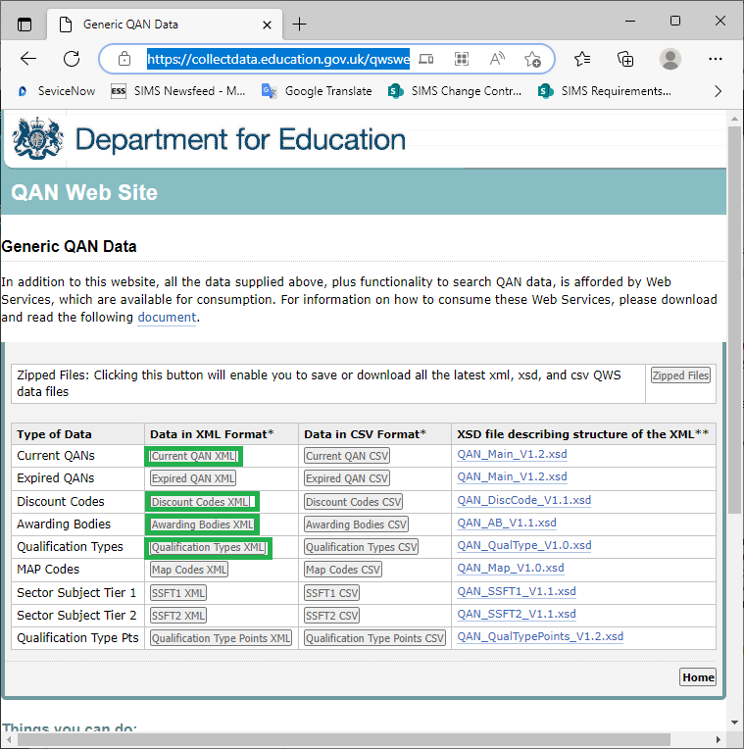
2. Have the most recent files from DfE QWS been imported via the Select Catalogue Files panel of Tools | Examinations | Import Qualification Data? Yes/No.
If Yes, proceed to Q3 below.
If No, import those files before proceeding.
Tools | Examinations | Import Qualification Data
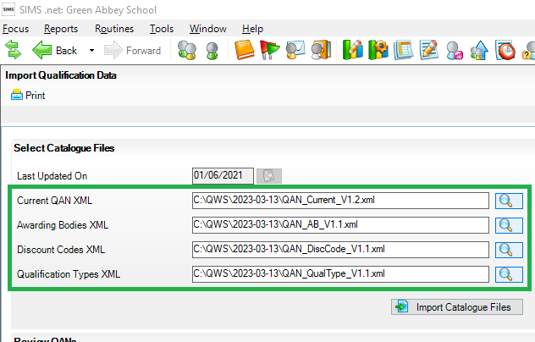
3. Is the QN plus discount code missing when you search for it via Tools | Academic Management | Course Manager | Maintain Course Classification? Yes/No.
Tools | Academic Management | Course Manager | Maintain Course Classification
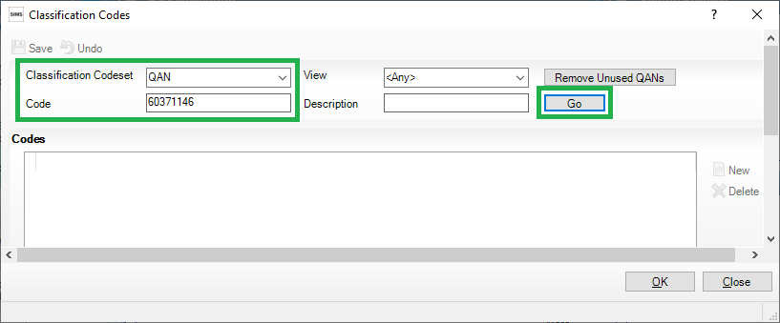
If Yes, proceed to Q4 below.
If No, ensure that the QN plus discount code is set to 'active' and make it available to Maintain Course via Tools | Academic Management | Course Manager | Updated QANs and Discount Codes for Course Manager and do not proceed.
4. Is the QN plus discount code present in the Ofqual Register of Regulated Qualifications ? Yes/No.
https://register.ofqual.gov.uk/
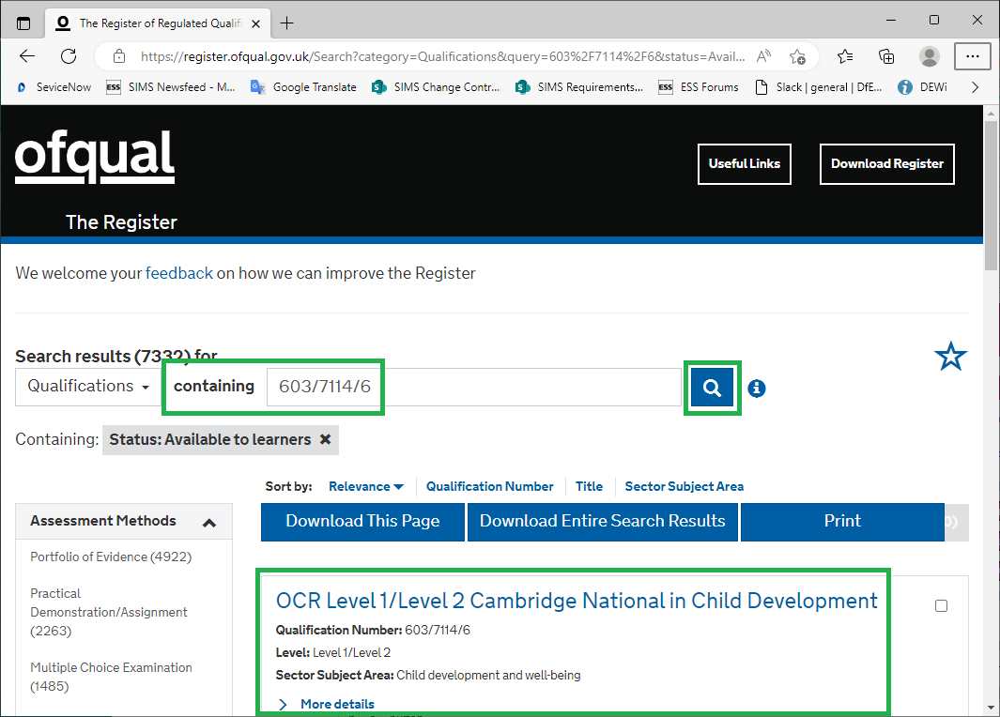
School in Wales may also want to check the Qualifications Wales website.
If Yes, proceed to Q5 below.
If 'No', do not proceed.
5. Are you sure that the QN plus discount codes isn't funded for post-16? Yes/No.
If Yes, proceed to Q6 below.
If No, please raise this with the DfE, so the DfE can look into making the QN plus discount code available via their QWS as necessary and do not proceed.
6. Are you sure that you have obtained the following information from a reliable source, e.g. the awarding organisation's specification website? Yes/No.
This is an example of the information needed.
- QN: 60371146 ^{*1}
- Discount Code: PT21 - Childcare Skills ^{*1}
- Title: OCR Level 1/Level2 Cambridge National in Child Development
- Awarding Body / Board: 110 - Oxford, Cambridge and RSA Examinations ^{*2}
- Qualification Type / Level: OCA - OCR Cambridge National Award ^{*2}
- Expiry Date / Certification End Date (if available): 06/06/2079
^{*1} A QN plus Discount Code combination must be unique.
^{*2} A QN can only have one Awarding Body and one Qualification Type regardless of the Discount Code it is linked to.
If Yes, use Tools | Examinations | Add Qualification Data to add the necessary information for creating a QN plus Discount Code.
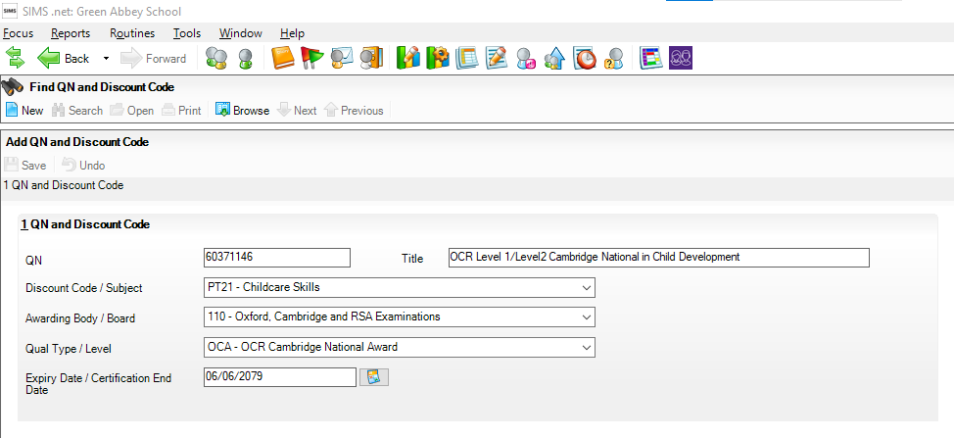
If No, obtain the information you need before attempting to create a QN plus Discount Code.

