Report Name | What does it do | Example Screenshot
MIDAS % Attendance Primary 2018/19  Or  MIDAS % Attendance Secondary 2018/19 | A very powerful attendance report, split over 3 tabs in Excel:  Percentage attendance tab:  Gives you figures for a large number of groups (incl Pupil Premium, non Pupil Premium, FSM, EAL, Boys, Girls, split by SEN and more) for the selected date range.  Student Details tab:  Provides attendance information for all individual pupils. Manually typing into the required % present box at the top of this spreadsheet will highlight in red any children not achieving the required present %.  Applying a filter to any column will change the figures in the boxes at the top to show results for only the filtered groups.  PA group tab:  Shows the percentage attendance for pupils hitting the persistent absence marker, splitting them down into the same groups as the Percentage attendance tab | 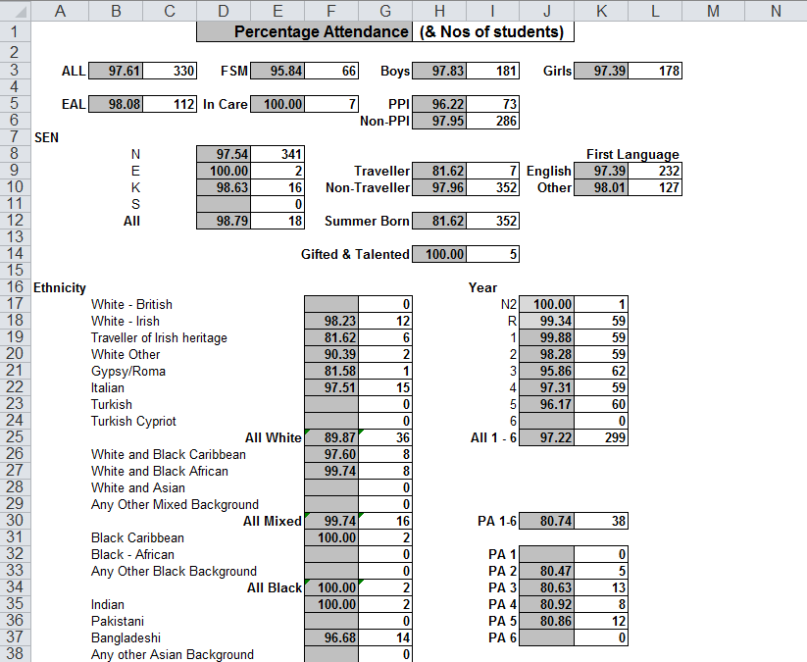  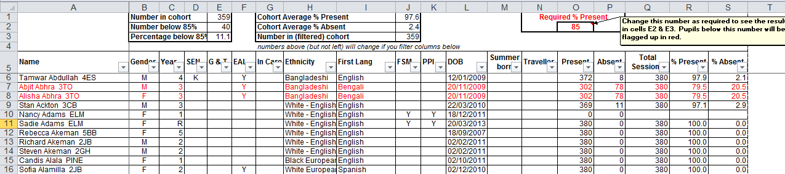
MIDAS Medical Conditions and Notes | Lists Medical Conditions and Medical Notes (in separate tables to remove any duplication) for pupils. Date information was entered appears in brackets.  Using the filters when running the report, this can be run for individuals, groups, or the whole school. | 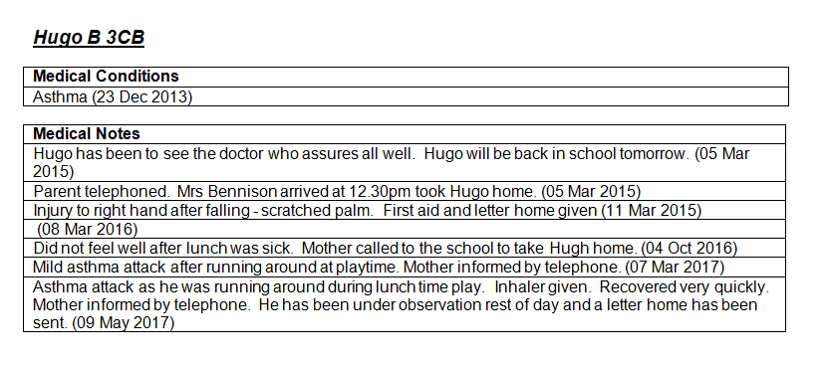
MIDAS Parental Consent Excel Report | Produces an excel report, detailing your consent types across the top (please contact us if you need assistance editing the report to include your own consent types) showing 1 for True and 0 for False. Find and Replace can be used to change 1 to T and 0 to F to make this report easier to read. | 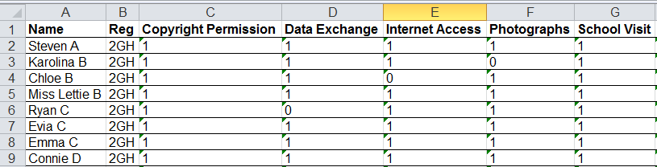
MIDAS Parental Consent Report | Produces a Word report, showing Parental Consent given in one column, and not given in the other. All permissions will show in the relevant column. | 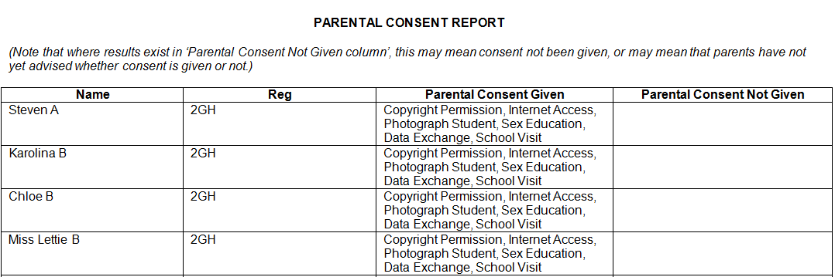
MIDAS Parental Consent Report (single) | Gives users the option to select an individual consent type, and required group(s), and produces a word document showing 1 for True and 0 for False  (Text shown in red will need to be entered manually when report has been run) | 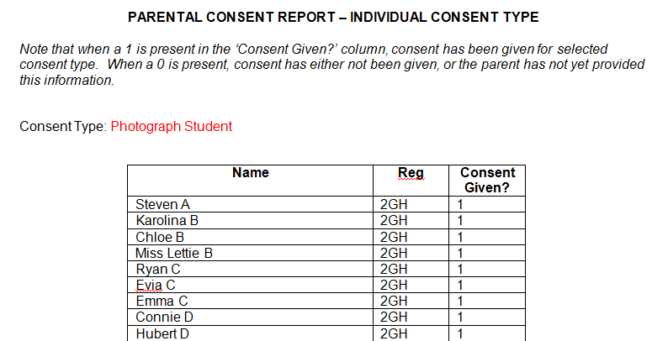
MIDAS Pupil Analysis Report | SIMS Analysis report that allows school to quickly find numbers and percentages of children in particular key pastoral groups across the school, by changing the selections in the Row and Column drop down menus | 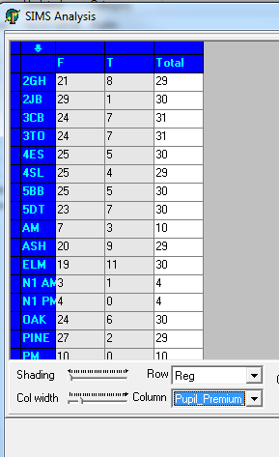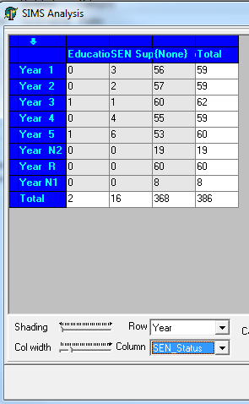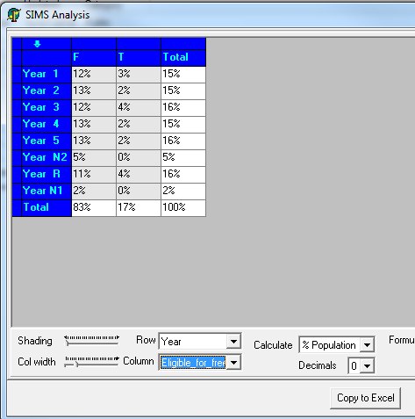  Count of PP split by Reg Count of SEN split by Year % pupils with FSM split by Year
MIDAS Sibling Links | Excel report showing pupils identified by the system as being siblings (so showing in the sibling links box on the family/home panel). | 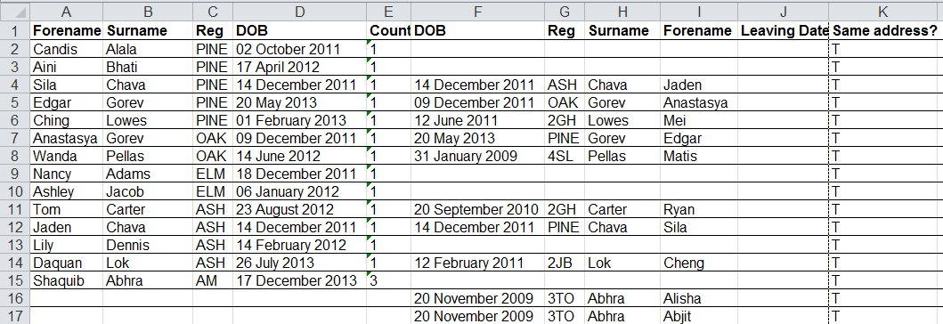
MIDAS Achievement and Behaviour Reports | Excel reports showing total behaviour points, or total achievement points, per pupil, for a given date range. Shown as a pivot table with ability to filter on year and group. | Achievement Report Behaviour Report  