Importing and running the Y code Report

You can use these instructions for downloading/detaching and saving any reports.
Detaching & Saving your Report

- Click on the Report in your email and select Download or (Save As if you have that option available)

- Save to a shared location (e.g. Y:\SIMS)

NB: Please note when you click on Download the report may download to your Downloads folder. if this is the case, you will need to find the report in the Downloads folder, highlight, right click, select to either copy or cut then paste in a location you will be able to find when you are ready to import eg Y:\MIS

Importing the Report

- In SIMS, go to Report – Import
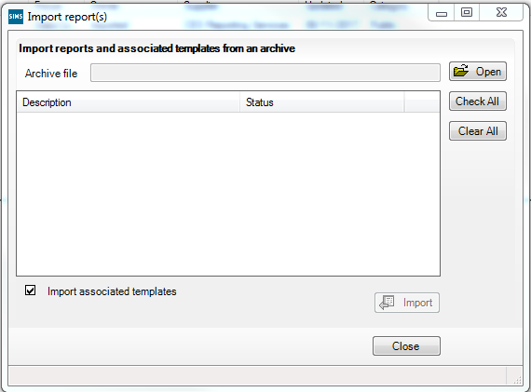
- Click Open, navigate to the location you saved the Report to, and double
- Highlight Report
- Click Open

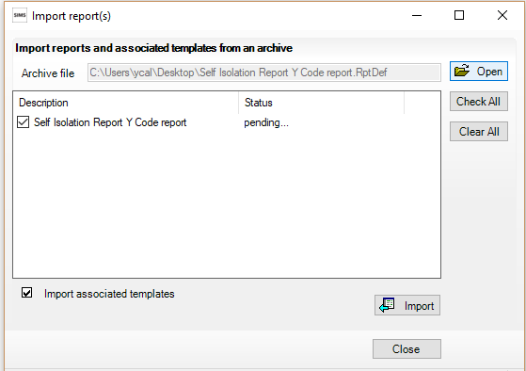
5. Click Import
6. Click Close

Your report is now ready to run.

Running the report
- In SIMS, go to Reports – Design / Open an Existing Report

- Click the + next to Focus, + next to Student select the Report

- Double click on the report Report (You can at this stage right click on the report SIMS – Self Isolation Y Code and send to Favourites this will put a copy of the report on your SIMS home page)

- Select the date range you wish to report on

- Click OK to run the report
- The report will open in Excel in student alphabetical order.

If you wish to use the filters for example to filter on reg or year groups etc, highlight the row displaying Name, Year, Reg, Mark, Mark date,
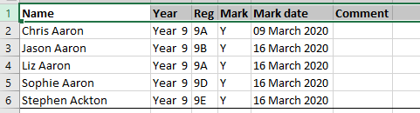

Then click on Data, then click on Filter. You will now be able to use the drop-down menus to make your selections.

