Exceptional Circumstances
for Self-Isolating students

If you need to use the Y Attendance code for self-isolating students, then please see instructions below.

The Y code does not affect the child’s percentage attendance.
NB: If you have already used an absence code e.g. I or C code, you will need to remove this first through Edit Marks.

To add the Y code:

- Use route Focus / Attendance / Exceptional Circumstances
or Secondary Schools Focus / Lesson Monitor / Exceptional Circumstances
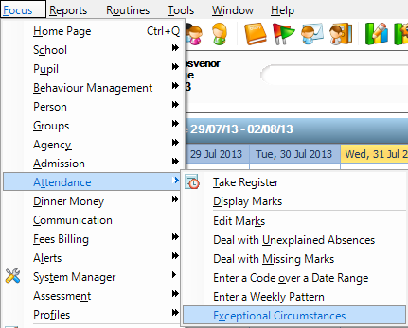

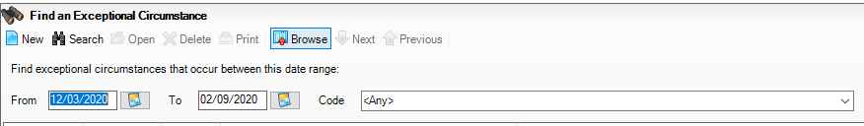
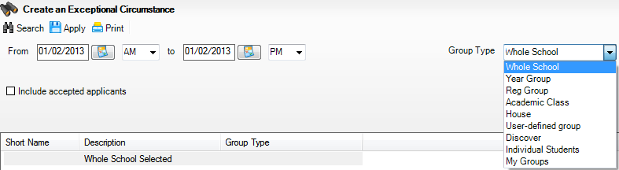
- Click on New at the top of the screen.

- Select required dates and enter the dates the student will be away from school

- Select Group Type. Select your group, if its an individual, select Individual Students.

- Click Search to bring through your select Group Type

- If you have a number of students you wish to apply the Y code, depress the Ctrl Key keep Ctrl key down then select all those students to whom you wish to apply the code.

- Next from the drop down menu, select code Y
. 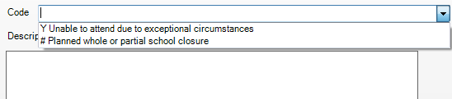
- Enter a brief description of what the closure is for eg Self-isolating.
Once completed, click the Apply button at the top of the screen. (If you wish, you can check in Focus / Attendance / Display Marks or Secondary Schools Focus / Lesson Monitor / Display Marks and choose one of the students to whom this mark has been applied, and to check the mark is displayed correctly.)

